
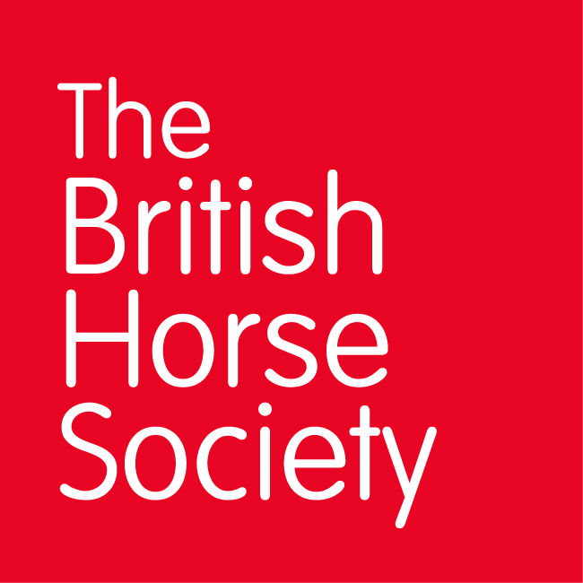
BRC CHAMPIONSHIPS 2025
AREA 8 SUMMER QUALIFIER DATES

COMPETITION | DATE | VENUE | ORGANISER | Official  Steward
National Champs (Dressage) | 04/05/2025 | Berwick Farm, Stanford Rivers, Ongar CM5 9PY | Colleen Taylor | Katie Pittaway
National Champs (Show Jumping) | 25/05/2025 | Tendring Hundred Riding Club Showground, Weeley, Essex CO169JH | Jo Mason | Katie Pittaway
Horse Trials | 15/06/2025 | Ely Eventing Centre | Rachel Casbon (Run with area 7) | Katie Pittaway
Combined Training | 06/07/2025 | Frenches Farm Livery, Oxen End, Great Bardfield, Uk CM7 4PU | Claire Engelmann | Katie Pittaway
Combined Challenge | 24/08/2025 | Horseheath Racecourse, Horseheath Racecourse, Cambridge CB21 4QP | Claire Engelmann | Katie Pittaway
Closing dates for all qualifiers are 21 days before the event.
Please note qualifiers should be held at least 28 days before the Championship date.

