INTRODUCTION TO DATA PROTECTION

New European data protection regulations (GDPR) came into force in 2018. Although the UK has left the European Union, these regulations still apply, alongside a new set of UK data protection rules.

- If you work solely with UK based staff and customers, then you are bound by UK GDPR.
- If you work with staff or customers in the EU or who are EU citizens, then you must abide by BOTH sets of requirements.

Whether you are a large employer or an individual APC, you have a responsibility to follow the new data protection rules and be able to demonstrate how you comply with them.

When anyone gives and trusts you with their personal information, it is your responsibility to treat this information in a way that lives up to their expectations and complies with all your legal obligations. A serious breach of data protection law could result in criminal prosecution and a fine of up to €20 million (or 4% of your global turnover, whichever is the greater). It would also seriously damage your reputation and future business potential.

Generally, a useful way of thinking about data protection is to treat people’s personal information in the same way that you would expect your own to be treated.

DATA PROTECTION TERMS AND DEFINITIONS

The key terms that you should understand are:

- Data controller – this is an organisation/person acting in a professional capacity that collects and decides how personal information will be used

- Principles – these are the rules that we must follow when processing personal information

- Processing - this is what we do with personal information. It includes how we collect, record, store, share and use personal information.

- Personal information – includes personal data and special category personal data

- Data Subject – the individual about whom you are collecting or using information.

- Personal data - this is information about people (living individuals) and held in computer systems, mobile telephones or in manual records such in paper files and notebooks. For example, name, address, date of birth, bank account details, interests. It also includes opinions about a person. For example, notes on how you think someone has behaved, performed or appears.

- Special category personal data – this is information about a person’s health, religion, political opinion, trade union membership, race or ethnic origin and sexuality.

- A data subject - this is the person whose personal information is being processed. For example, a staff member, assessment candidate, pupil.

- A privacy notice – this is how you inform people about how their personal information will be used

- Information Commissioner’s Office (ICO) - this is the UK government body responsible for enforcing data protection law in the UK

- Data Protection Lead - This is the individual within your organisation that has responsibility for managing and promoting data protection. If you are a sole trader, this is YOU.

- SAR (Subject Access Request) – this is any written request by a data subject for information you might hold about them.

- Data Breach – this is any loss, deletion or corruption of personal data that you hold, which would prevent the data subject from accessing or updating this information.

- Third Party Data – this is information about other data subjects in a set of personal data. For example, Sue Smith makes a Subject Access Request. In the email records that are found, there are emails to and from Sue but also emails about Sue and one also contains information about another client, Tracy. The email contains Sue’s data but also that of a third party: Tracy.

- Data Processor – this is any person or organisation that uses personal information you provide to ‘do something under your instruction. For example, if you have a database and an IT company supports it – they are your data processor; or if you send a list of clients to a mailing house so that they can send out letters or a magazine – then the mailing house is your data processor.

THE DATA PROTECTION RULES

Personal Information Must Be:

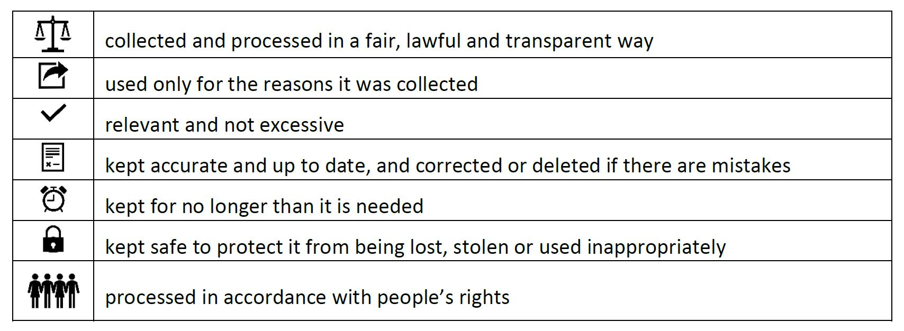

PRACTICAL GUIDANCE FOR COMPLIANCE

Personal data must be processed fairly, lawfully and in a transparent manner

- Be clear and open with people about how their personal information will be used
- include a written or verbal Privacy Notice when collecting personal information. This should describe:
  - who the data controller is. For example, the British Horse Society
  - the purpose for which the personal information will be used. For example, to enter a competition or sign up for an event
  - if the personal information will be shared with any other organisations
- Only use personal information in a way that people would reasonably expect
- Think about the impact of your processing – don’t do anything that could have a negative effect on the people whose personal information you are using
- Only collect and use personal information if there is a lawful basis for doing so. One of the following conditions must apply:
  - We have the consent of the person concerned
  - It is necessary for the performance of a contract
  - It is necessary to protect the vital interests of someone (when it is a matter of life and death)
  - It is necessary to meet a legal obligation
  - It is required to fulfil a public responsibility
  - The processing is within the legitimate interest of the data controller

- Obtain the explicit consent of a person if you are collecting their sensitive personal data. For example, health or medical information
- Keep a record of consent for using sensitive personal data

Personal information should be used only for specified, explicit, and legitimate purposes

- Only use personal information for the purpose that was described in the privacy notice when collecting it. For example, if the privacy notice states that the information collected will be used for a competition entry, that is all it can be used for.

Personal information must be adequate, relevant and not excessive

- Collect just the right amount of information for the purpose required and described in the privacy notice – no more, no less
- If a person gives you more information that you need to know, for example in an email or phone conversation, only record the relevant information
- Data protection law does not allow for personal information to be kept because ‘it might become useful’

Personal information must be accurate and up to date, with errors corrected or deleted as soon as possible

- Regularly check that the personal information you hold in computer and paper records is accurate
- At least once a year destroy or delete any records that are no longer needed. Do not use personal information if you have doubts about its accuracy
- Remind people to notify you of any changes in their personal information
- Amend your records as soon as possible if someone informs you of a change in their information

Personal information should be kept only for as long as it is needed

- We must have a valid reason for keeping personal information
- A data controller must document how long it will keep different types of records and personal information for in a Personal Data Retention Policy and Schedule
- When personal information is no longer required it must be destroyed or disposed of securely, for example shredded or via a confidential waste system

Personal information must be kept safely to prevent it from being lost, damaged or stolen

- Access to personal information should be on a need to know basis
- Use a password to log in to your computer so that others cannot access the personal information you hold
- If you share a computer with other people (even family members), ensure that your documents are password protected to prevent unauthorised access
- Make sure papers or screens containing personal information are not visible to others in meetings, on trains, and even in your own home
- Lock desks and cupboards used to store personal information, and keep the keys secure
- Use Royal Mail registered post to send large volumes of paper containing personal information or sensitive personal data
- If you need to send an email containing personal information, or attach a file which includes personal information to an email, password protect the email or document, and send the password in a separate email or text message
- Double check that you have attached the correct file before sending an email
- Double check that the email is addressed to the correct recipient
- Always use the bcc field (not the cc field) when sending an email to more than one person so that the recipients’ email addresses are not visible to each other - unless consent to share email addresses has previously been obtained
- Take special care when travelling with computers, laptops, tablets, smart phones and paper records containing personal information

Sharing personal information

- A person’s personal information must not be shared with another person or organisation without their prior consent. This includes contact details and email addresses
- If we need to share personal information with other organisations to process information on our behalf, for example, we may use a mailing company to post information for us, this detail must be included in the privacy notice
- We can share someone’s personal information without consent, if someone’s life is at risk

Personal data breaches

Personal data breaches occur when personal information is lost, destroyed or shared without consent, or if someone accesses the personal information or passes it on without consent. This can be deliberate or by accident. It includes sending personal information to the wrong person and electronic devices such as laptops and telephones containing personal information being lost or stolen. We must act quickly if there is an issue

- Data controllers must keep a record of all personal data breaches
- Serious breaches must be reported to the ICO within 72 hours of being discovered

Data subject rights

The data protection regulation gives rights to people. The rights that are most relevant to us are:

- The right to be informed – we do this by including appropriate privacy notice information when collecting personal information
- The right of access – if asked we must give people a copy of their personal information which we hold
- The right to object to direct marketing – if asked we must stop sending people direct marketing messages
- The right to rectification – we must correct any inaccurate or incomplete personal information when asked
- The right to erasure – we must delete or remove some personal information if asked

How to respond to data subject rights

The right of access

A person has the right to view their personal information which hold. When asked we must provide this information within one calendar month.

- The information provided must not include anyone else’s personal information unless we have their consent.
- Assume that anything you record about a person could be seen by that person.
- Record facts and opinion that you would be able to defend if challenged

The right to object

People have the absolute right to prevent their personal information being processed for direct marketing purposes. The definition of ‘direct marketing’ by the Information Commissioner’s Office includes an organisation communicating its aims and objectives by email, e-newsletter, telephone, text message or post. This includes information about campaigns, petitions, events and fundraising activities.

- You must only contact a person with a direct marketing message by electronic means (email, text message) if they have already opted in to receiving these communications by email and / or text message

Every direct marketing message you send by email and text message must include an unsubscribe function so that the recipient has a choice to opt out of further communications from the group

- A person must not be contacted again if they unsubscribe or request not to receive further direct marketing messages
- If someone contacts you to say that they no longer wish to receive direct marketing messages by post or phone call, you must remove their name from or suppress it in your group mailing list
- A person must not be contacted again if they have requested not to receive further direct marketing messages
.
The right to erasure

The right to erasure is also known as ‘the right to be forgotten’. People have the right to request the deletion or the removal of their personal information where there is no compelling reason for its continued processing. An example of this includes deleting an individual’s email address from your mailing list if they ask you to after they have opted out of receiving updates by email.

- If you have given a person’s personal information to someone else, you must contact each recipient of that information and ask them to erase the personal data in question
- If requested, you should also inform the person about the other recipients of their personal information
- If you have published personal information online, for example on social networks, forums or websites you should also erase the personal information from online platforms
- If you receive a right to erasure request and you’re unsure how to handle it, please get in touch with the BHS Data Protection Lead at: dataprotection@bhs.org.uk.

