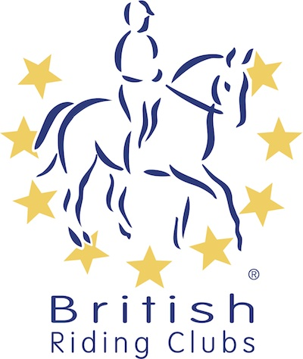
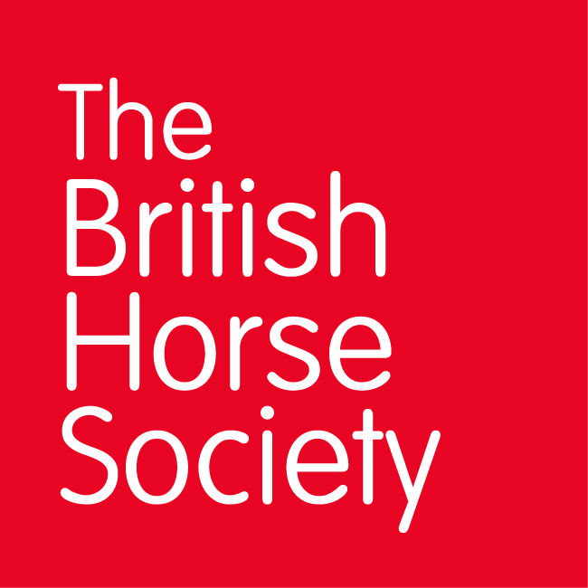
BRC CHAMPIONSHIPS 2025
AREA 12 SUMMER QUALIFIER DATES

COMPETITION | DATE | VENUE | ORGANISER | Official  Steward
Combined Challenge | 29/03/2025 | Tweseldown Equestrian Centre, Bourley Rd, Church Crookham, Fleet GU52 8AD | Tweseldown Racecourse | Jenny D’Entremont
National Champs (Dressage) | 18/05/2025 | East Byshee Equestrian, Rh7 6 Lf East Grinstead RH7 6LF | Sharon Warburton
Horse Trials | 25/05/2025 | Blindley Heath Horse Trials, Show Site, Blue Anchor Farm Cottages, Eastbourne Road, Blindley Heath RH7 6JL | Lucy Cunliffe (Joining Area 10)
Horse Trials | 08/06/2025 | Munstead Horse Trials, Heath Lane, Godalming, Surrey, GY7 1UN | Munstead Horse Trials
National Champs (Show Jumping) | 14/06/2025 |  | Caroline Exley
Combined Training | 29/06/2025 | Felbridge Show Ground, Copthorne Rd RH19 2NU | Caroline Exley
Closing dates for all qualifiers are 21 days before the event.
Please note qualifiers should be held at least 28 days before the Championship date.

