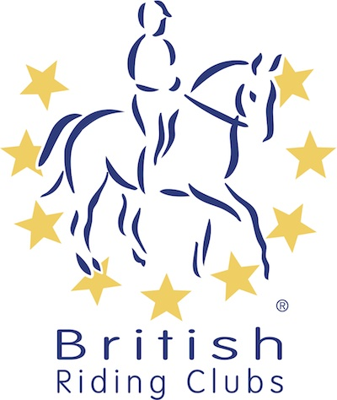
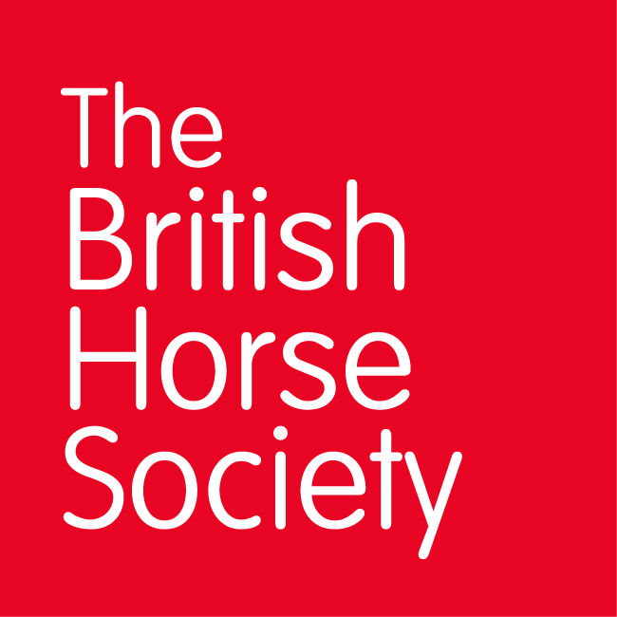
BRC CHAMPIONSHIPS 2025
AREA 12 SUMMER QUALIFIER DATES

COMPETITION | DATE | VENUE | ORGANISER | Official  Steward
National Champs (Show Jumping) | 19/04/2025 | Bicton Arena, East Budleigh, Budleigh Salterton EX9 7 | SOVRC | Lindsay Opperman
Horse Trials | 17/05/2025 | Pontispool Equestrian Centre, Pontispool Farm, Taunton TA4 1BG | Ros Burridge e-mail: | Sally Ellis-Gray & Martin Boreham
Combined Training | 08/06/2025 | Stockland Lovell | Taunton | Sally Ellis-Gray & Lindsay Opperman
National Champs (Dressage) | 05/07/2025 | Chard | West Dorset & District RC | Lindsay Opperman
Combined Challenge | 13/07/2025 | Downe Farm | Witheridge & District RC | Anna Ames
Closing dates for all qualifiers are 21 days before the event.
Please note qualifiers should be held at least 28 days before the Championship date.

