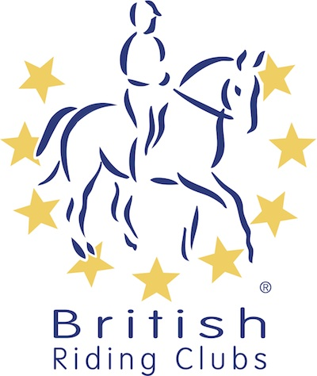
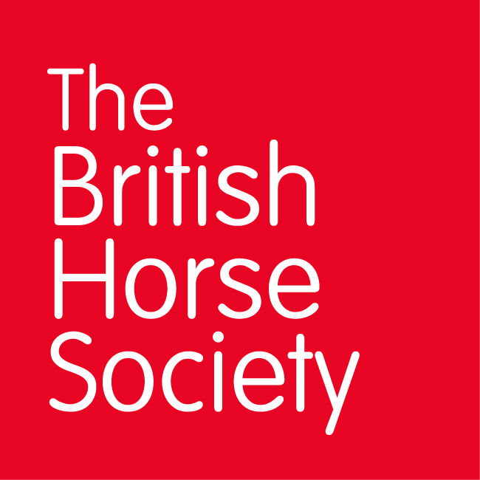
BRC CHAMPIONSHIPS 2025
AREA 4 SUMMER QUALIFIER DATES

COMPETITION | DATE | VENUE | ORGANISER | Official  Steward
Horse Trials | 18/05/2025 | Smallwood Livery Centre, Brookhouse Farm, Brookhouse Green CW11 2XE | Jayne Hawley | Jann Crossland
Dressage (Lincoln) | 20/07/2025 | Bold Heath Equestrian Centre, Warrington Road, Widnes, Cheshire, WA8 3XT | Jayne Hawley | Jayne Hawley
Show Jumping (Lincoln) | 29/06/2025 | Bold Heath Equestrian Centre, Warrington Road, Widnes, Cheshire, WA8 3XT | Jayne Hawley | Denise Newsome
Combined Challenge | 23/08/2025 | Bold Heath Equestrian Centre, Warrington Road, Widnes, Cheshire, WA8 3XT | Jayne Hawley
Combined Training | 13/04/2025 | Bold Heath Equestrian Centre, Warrington Road, Widnes, Cheshire, WA8 3XT | Jayne Hawley | Jayne Hawley
Closing dates for all qualifiers are 21 days before the event.
Please note qualifiers should be held at least 28 days before the Championship date.

