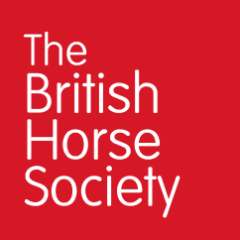0

00000 000 000

EVENT CONTACT NUMBER:

PLEASE FOLLOW THE INSTRUCTIONS IN YOUR EVENT PACK PROVIDED

The British Horse Society is a Registered Charity Nos. 210504 and SC038516