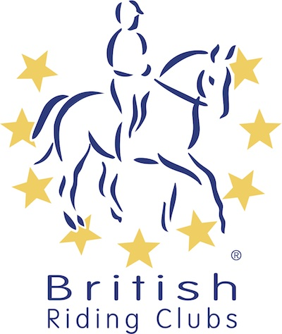
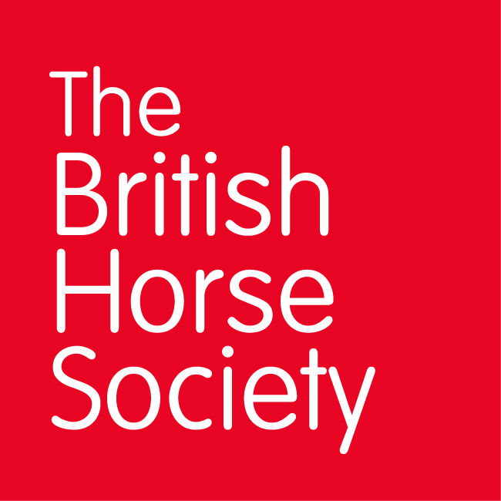
BRC CHAMPIONSHIPS 2025
AREA 14 SUMMER QUALIFIER DATES

COMPETITION | DATE | VENUE | ORGANISER | Official  Steward
Horse Trials | 18/05/2025 | Poplar Park, Hollesley, Nr Woodbridge, Suffolk, IP12 3NA | Julia Sheppard | Ann McVicar annmcvicar@btinternet.com
National Champs (Show Jumping) | 22/06/2025 | Geldeston Hall, NR34 0LP | Julie Frost | Ann McVicar annmcvicar@btinternet.com
National Champs (Dressage)
Combined Training
Combined Challenge
Closing dates for all qualifiers are 21 days before the event.
Please note qualifiers should be held at least 28 days before the Championship date.

