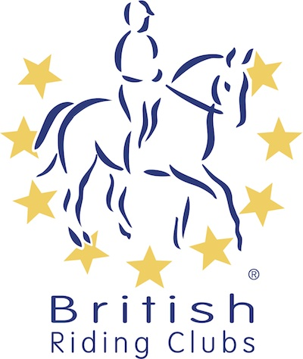
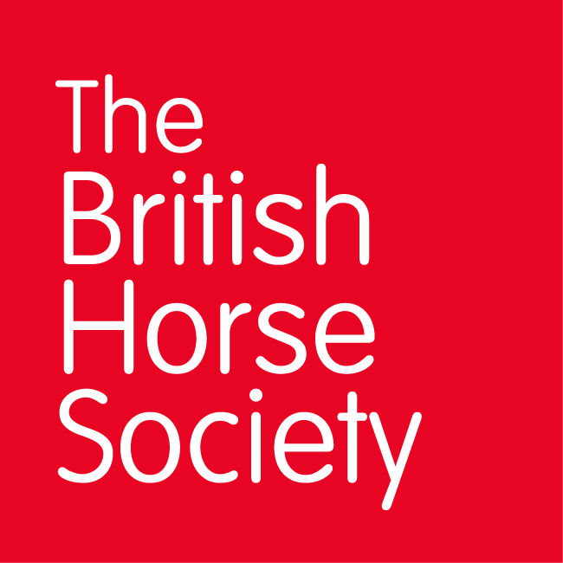
BRC CHAMPIONSHIPS 2025
AREA 20 SUMMER QUALIFIER DATES

COMPETITION | DATE | VENUE | ORGANISER | Official  Steward
Combined Challenge | 04/05/2025 | Solihull Riding Club, Four Ashes Road Bentley Heath, Solihull B93 8QE | Tony Parker (Joining Area 5) | Tony Parker
National Champs (Dressage) | 28/06/2025 | Somerford Park TBC | Nantwich
Horse Trials | 05/07/2025 | Kelsall Hill Equestrian Centre, Tarporley CW6 0SR | Area 20 /Pony Club
Combined Training | 31/08/2025 | Bryn Derw Farm, Brynrefail, LL55 3PD | Caenarfon RC (Provisional Date)
National Champs (Show Jumping)
Closing dates for all qualifiers are 21 days before the event.
Please note qualifiers should be held at least 28 days before the Championship date.

