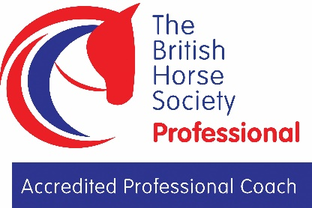
The Update Service Permission Form

The Disclosure and Barring Service (DBS) update service lets applicants keep their DBS certificates up to date online, allows employers to check a certificate online and enables your certificate to be portable in some situations. You must sign up to this service via the DBS using your DBS certificate number and by paying the annual subscription fee of £13 to the Disclosure & Barring Service.
In order for the British Horse Society to access your online record we need your permission to keep the details linked to your membership record. Please complete the information below and return to the Accredited Professional Coaches Team.
Name (as it appear on your DBS Certificate)
BHS membership number
DBS Certificate Number
(not reference number )
Date of Birth
Telephone number
Email
I consent to the British Horse Society storing my update service number along with my membership record and a copy of my DBS certificate.
I consent to the British Horse Society using my details to perform a status check at regular intervals as governed by the requirements of the Accredited Professional Coaches Register.
I consent to the BHS sharing this information with other British Equestrian Federation Member Bodies e.g. pony club.
I agree to inform the British Horse Society if my situation changes in the future and I understand the BHS will archive my details should I no longer remain as a BHS Accredited Professional Coach.
Additionally, we may (subject to your consent) disclose your personal information to subsidiaries, with trusted service providers and selected partners so that they can contact you with information about their products and services. But don't worry; your details won't be shared without your consent.
If you agree to your information being shared in this way, please tick this box □
To see our full Privacy Policy, please go to http;//www.bhs.org.uk/privacy
Signed (or print if emailed) Date
Print name
Please return to the Accredited Professional Coaches, The British Horse Society, Abbey Park, Stareton, Kenilworth, CV8 2XZ
BHS Safeguarding Team
02476 840746
safeguarding@bhs.org.uk
Registered Charity Nos. 210504 and SC038516
Registered Charity Nos. 210504 and SC038516
or email accreditedprofessionals@bhs.org.uk

