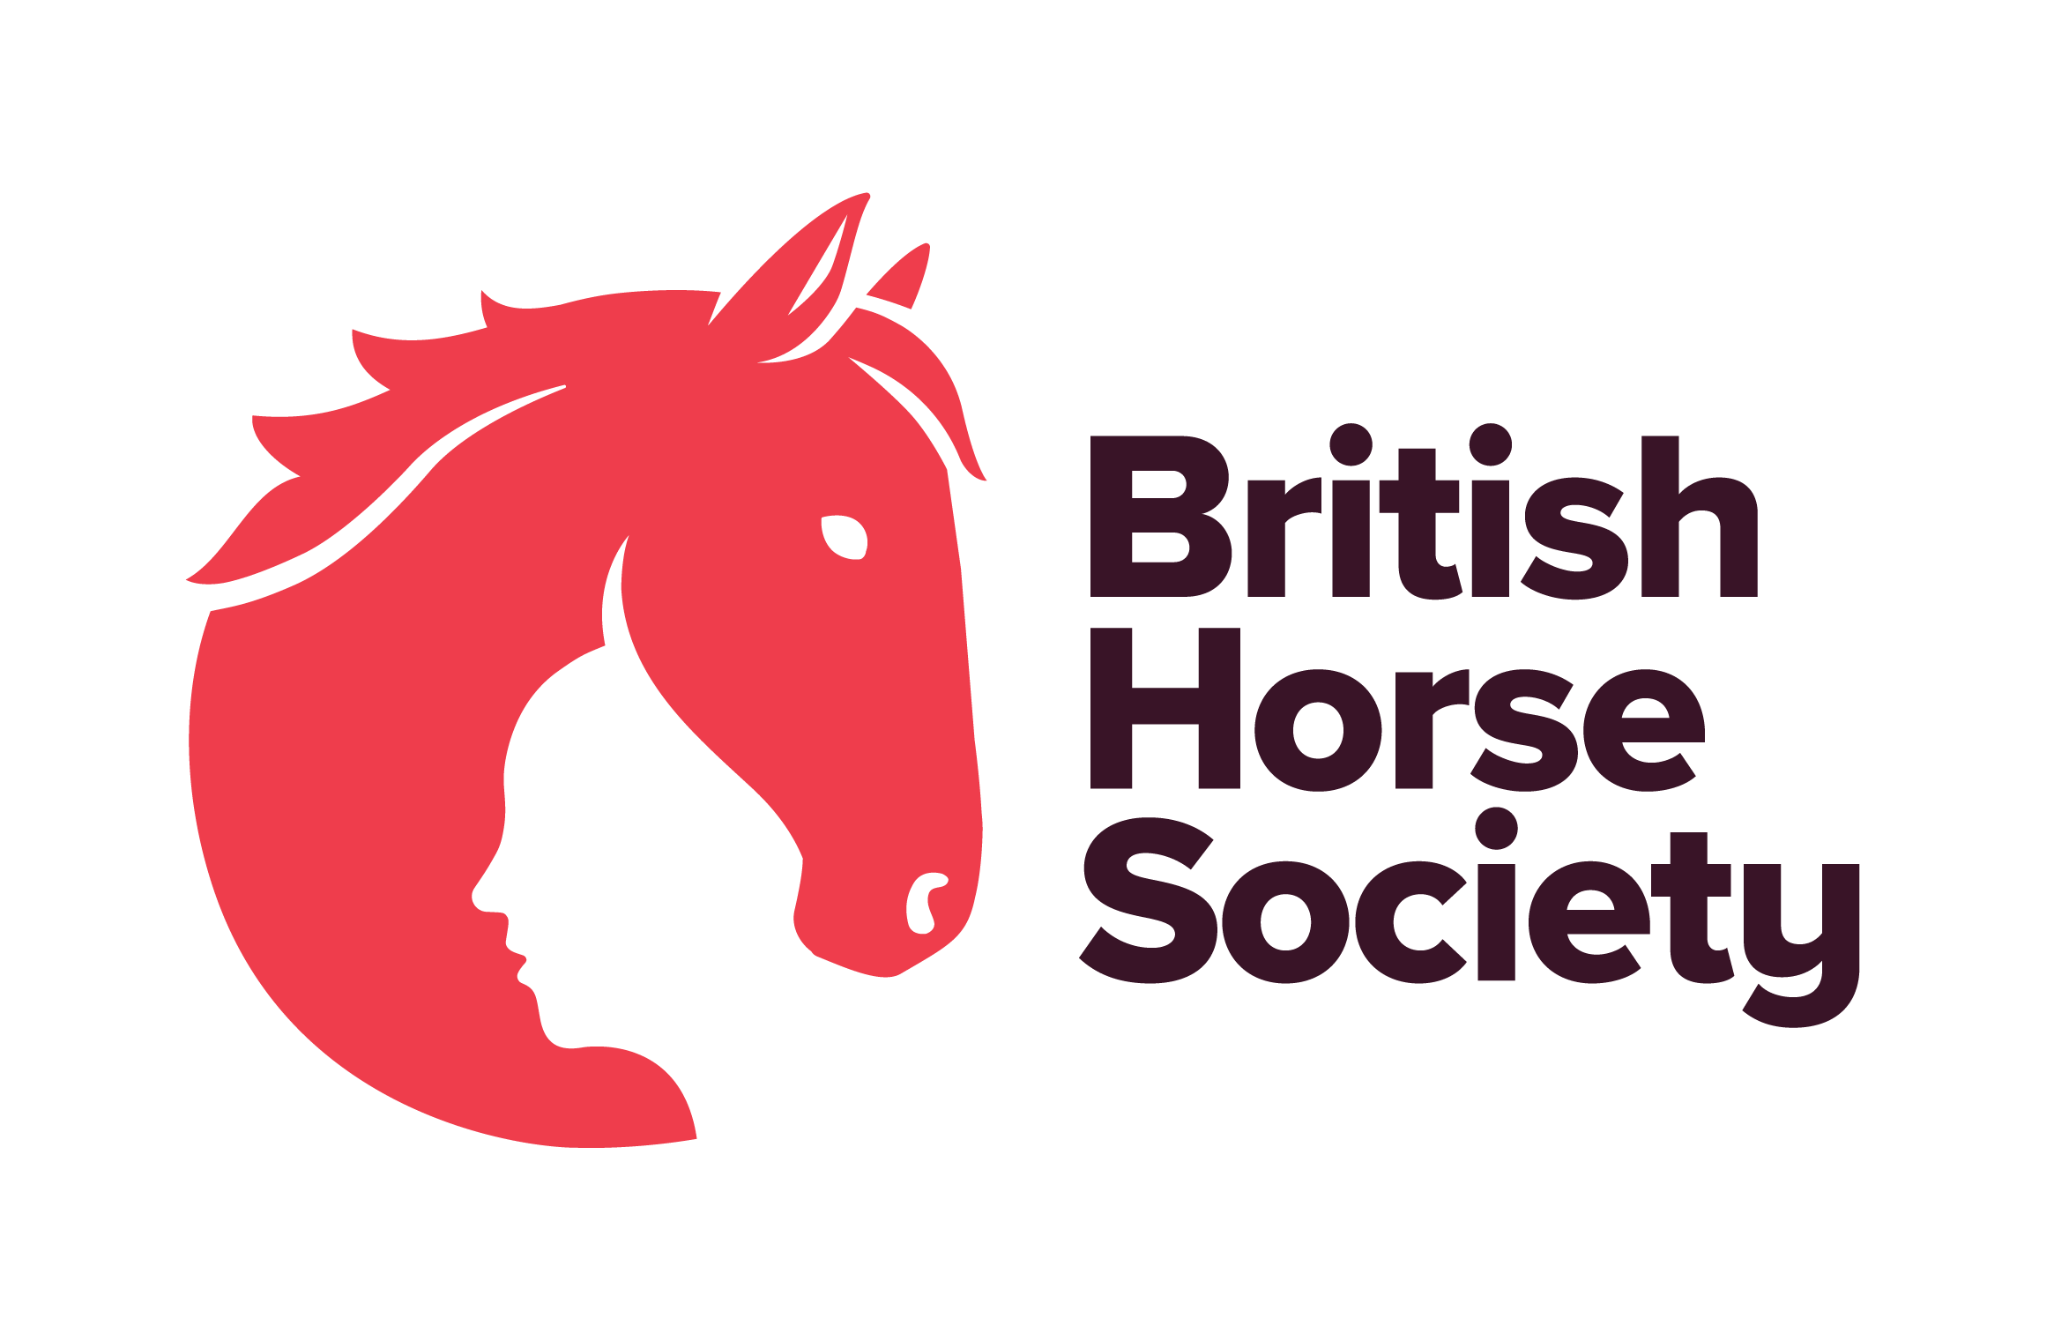

BHS Terms and Conditions

Terms and conditions provide clarity about what should or will happen in any given situation. They set out the key terms you are offering to your clients and help others to understand their duties, rights, roles, and responsibilities. It is recommended that every event run on behalf of BHS has Terms and Conditions which apply to that event.

Select and use those which apply to your event or use these suggestions to create your own. This is not a definitive list, so if there is anything specific relating to your event that needs to be included, please add this. Any items marked in red are mandatory and must be included in your own Terms and Conditions.

General
- Advance bookings are classed as those made or received before [insert time] on [insert date].
- All entrants must hold third party public liability insurance either through being a Gold member of British Horse Society or via proof from another provider.
- Entries on the day are by cash only.
- Online entries only, no cash will be taken on the day.
- Tickets are non-transferable.
- Please report to the organisers on arrival.
- Always follow the instructions of marshals and officials.
- Registration opens at [insert time] and closes at [insert time].
- Horses may start at any time between [insert time] and [insert time].
- You will be asked to provide emergency contact details, vehicle make, model and registration on arrival.
- Everyone attending the event is responsible for ensuring the safety of themselves and others.
- BHS, or the training venue, cannot provide supervision for attendees under the age of 18. Any attendee below the age of 16 years should be accompanied by a responsible adult who remains at the venue for the duration of the course or event. For attendees aged 16-17, or an adult at risk, it is at the discretion of their parent or guardian and agreed in advance with BHS or the training venue.
- Accompanying adults may need to pay to attend the event, this is at the discretion of the event organiser.
- Please leave the parking area as you found it – don’t muck out your trailer or lorry in the parking area and take dung home with you.
- Dogs are permitted but MUST always be kept secured on a lead.
- Dogs are NOT permitted.
- We may use photos, video, and information about you on BHS social media, website or magazines. You have the right to withdraw your consent at any time by emailing dataprotection@bhs.org.uk.
- For more details about how your personal data is used please take a look at our Privacy page: www.bhs.org.uk/privacy or contact dataprotection@bhs.org.uk.
- This event is being run under the BHS Code of Conduct for Welfare of Horses at Events and Activities.

Riders
- Hats to the current standard must always be worn and correctly secured when mounted. Please check yours meets current standards which can be found at: https://www.bhs.org.uk/go-riding/riding-out-hacking/what-to-wear/hats-and-helmets/.
- Body protectors are strongly recommended and should comply with current standards – also found on the BHS website at http://www.bhs.org.uk/body-protectors.
- Hats and body protectors (if you choose to wear a body protector) will not be checked. It is your responsibility that these are to the current standards. Please refer to https://www.bhs.org.uk/advice-and-information/tack-and-equipment/what-to-wear.
- All riders must wear suitable riding footwear. Wellington boots and trainers are not allowed.
- No one must sit on/ride a horse unless they are booked as the event participant and have appropriate insurance cover.
- Unless directed by a medical professional, or event official or the rules of a competition, riders continue to ride after a fall at their own discretion.
- BHS strongly recommends wearing hi-viz when riding and carriage driving.
- Hi-viz clothing must be worn on the horse and rider.
- Hi viz tabards will be provided and must be worn (£5 refundable deposit required). All tabards to be returned at the end of the ride.
- Riders under 16 years must be accompanied by a responsible adult for the duration of the event.
- Riders over 16 and under 18 may ride unaccompanied at the discretion of their parent or guardian.
- Riders are advised to carry a mobile phone and be aware of the emergency contact number for the event.
- All riders must have previous experience of riding the horse they have entered.
- Riders should have an appropriate level of fitness to safely undertake the activity.
- Riders should be of an acceptable size to ride the horse they have entered.
- A weight limit of [insert weight] applies to this event.
- All riders, whether they have completed the ride or not, must report their return to the organiser.
- Always ride and carriage drive with courtesy, care and consideration to fellow users of the route including equestrians, cyclists, walkers, particularly those who may be elderly, disabled, children, or simply be frightened of horses. Ride slowly past others.
- If the event incorporates using a road, ensure the Highway Code is adhered to.
- Do not stray from the planned route or designated areas. Remember horses’ hooves can damage surfaces in wet weather.
- Leave gates as you find them and ride slowly past any livestock.

Horses
- All horses must be no younger than four years of age and be of an appropriate fitness level for the activity being undertaken – hooves and shoes must be in good condition.
- It is the rider’s responsibility to ensure their horse is fit and healthy enough to complete the chosen distance comfortably.
- Tack must be suitable, in safe condition and fit correctly.
- Any stallions must be informed to the organizer at the time of booking. No person may bring a stallion without ensuring, at all times, that other riders, horses and members of the public are not at risk. Stallions should be identifiable by a bridle tag and/or yellow tail ribbon. Any stallions deemed to be unsafe by the organiser may be directed to leave the site.
- All horses must be up to date with annual equine influenza vaccinations and must be 6 days clear from their most recent booster vaccination. Further vaccination guidance can be found using the BRC Flu Vac Checker. (Before 1 Jan 2024) (After 1 Jan 2024). Spot checks will/may be made at the event.
- Horses should not be left unattended when tied to horseboxes, in the parking area or on the ride.
- It is a legal requirement to have your horses’ passport when travelling to events.

Cancellations and Refunds
- Strictly no refunds, except if the event is cancelled due to unforeseen circumstances.
- Strictly no refunds for anyone who has booked and does not attend.
- Cancellation can be made via email to (insert email address) up to (insert time/date/hours) prior to the event.
- A refund, less the booking fee charge, will be given to anyone who cancels up to (insert time/date/hours) prior to the event.
- No entries will be refunded without a medical or vet’s certificate.
- If the event is cancelled by BHS, the entry fee will be refunded less the administration cost.
- If the event is cancelled by BHS, the entry fee will be fully refunded.
- In the case of cancellation by the attendee [£ insert amount} will be retained to cover admin and booking fees.
- All British Horse Society events are checked for viability around ten working days beforehand. Any that have insufficient numbers may be cancelled. In this case, delegates who have booked will receive a full refund or free transfer should another suitable event be pending.

Online Events
(Use this statement if the event IS NOT being recorded for use on BHS Wise)
Privacy Notice
- Please be aware that some events may be recorded. Images/videos will be used for general publicity including, but not limited to, BHS website, British Horse magazine and social media. If you do not want to be seen or heard it is your responsibility to ensure your camera and microphone are turned off, however your name may still be displayed.
- For more details about how we use your personal information, please see the full Privacy Notice on our website: www.bhs.org.uk/privacy or contact dataprotection@bhs.org.uk.

(Use this statement if the event IS being recorded for use on BHS Wise)
Privacy Notice
- Please be advised that this webinar will be recorded for training purposes and will be used across BHS platforms for a period of up to 24 months.
- If your camera is turned on, your image will be visible to individuals viewing the training content. Additionally, if you choose to participate in the chat or ask questions, your name may be displayed to viewers.
- For more information about how we use your personal information, please see the full Privacy Notice on our Website: www.bhs.org.uk/privacy.
- If you have booked a ‘watch on demand’ ticket, the recording will be sent to you after the event and will be available for (insert number) days for you to watch back.
- Sessions will be recorded; you will be able to request a copy of the recording after the event, within 7 days of the event.
- BHS does not accept any responsibility for your personal IT equipment or internet connection which may affect your ability to access this online event.
- BHS cannot be held responsible for broadband, or connectivity issues experienced during these sessions.
- It is the responsibility of the attendee to ensure they have joined the training in time for the start at (insert time). CPD hours will only be allocated if the participant attends the whole event. Anyone joining the training late will not be allocated CPD hours.

www.bhs.org.uk
www.facebook.com/TheBritishHorseSociety
www.twitter.com/britishhorse (@BritishHorse)
Disclaimer
The organisers have taken reasonable precautions to ensure the health and safety of everyone present. For these measures to be effective, everyone must take reasonable precautions to avoid and prevent accidents.

The British Horse Society is a Registered Charity Nos. 210504 and SC038516

