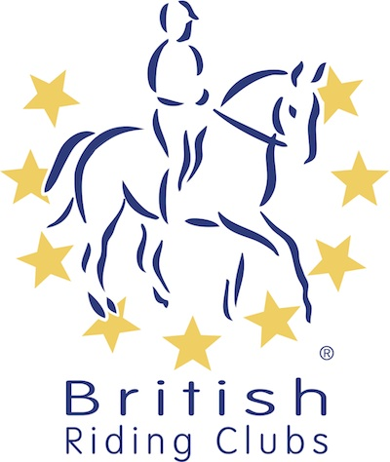
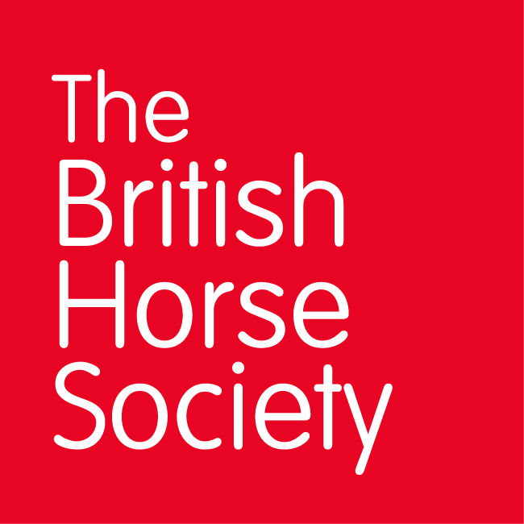
BRC CHAMPIONSHIPS 2025
AREA 5 SUMMER QUALIFIER DATES

COMPETITION | DATE | VENUE | ORGANISER | Official  Steward
Combined Training | 13/04/2025 | Solihull Riding Club, Four Ashes Road Bentley Heath, Solihull B93 8QE | Tony Parker | Tony Parker
Combined Challenge | 04/05/2025 | Solihull Riding Club, Four Ashes Road Bentley Heath, Solihull B93 8QE | Tony Parker | Tony Parker
National Champs (Dressage) | 22/06/2025 | Moreton Morrell College, Warwickshire College Moreton, Warwick CV35 9BL | Tony Parker | Tony Parker
Horse Trials | 05/07/2025 | Offchurch Bury | Tony Parker | Tony Parker
National Champs (Show Jumping) | 27/07/2025 | Solihull Riding Club, Four Ashes Road Bentley Heath, Solihull B93 8QE | Tony Parker | Tony Parker
Closing dates for all qualifiers are 21 days before the event.
Please note qualifiers should be held at least 28 days before the Championship date.

