
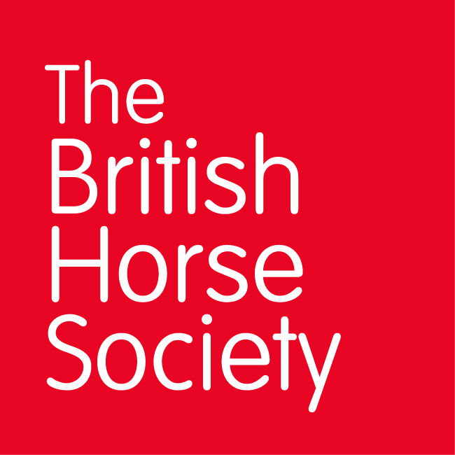
BRC CHAMPIONSHIPS 2025
AREA 1 SUMMER QUALIFIER DATES

COMPETITION | DATE | VENUE | ORGANISER | Official  Steward
Horse Trials | 15/6/25 | Ivesley Equestrian Centre. Ivesley Lane. Waterhouses. DH7 9HB | Hilary McKenna (area 2) | Hilary McKenna
Dressage (Lincoln) | 12/7/25 | Morris EC, Meikle Mosside Farm, Kilmarnock KA3 6AY | Jane McDowell | Maggie Bunnett
Show Jumping (Lincoln) | 13/7/25 | Morris EC, Meikle Mosside Farm, Kilmarnock KA3 6AY | Jane McDowell | Maggie Bunnett
Combined Challenge | 17/08/25 | Ivesley Equestrian Centre. Ivesley Lane. Waterhouses. DH7 9HB | Hilary McKenna (Area 2) | Hilary McKenna
Combined Training | 12/7/25 | Morris EC, Meikle Mosside Farm, Kilmarnock KA3 6AY | Jane McDowell | Maggie Bunnett
Closing dates for all qualifiers are 21 days before the event.
Please note qualifiers should be held at least 28 days before the Championship date.

