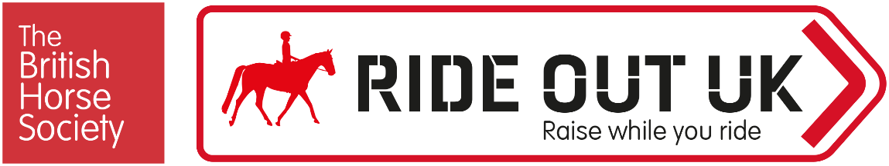

Enter ride name, date, time and details here

Rider Details
Full name
Address
Contact Number
Email Address
☐ I am over 18
☐ I am over 16 but under 18, and will be riding unaccompanied by an adult
☐ I am under 16 and will be accompanied by an adult
Signature (Parent/Guardian if under 16)

Insurance
All riders must have public liability insurance, valid on the day of the event. BHS Gold Membership includes up to £30 million public liability insurance cover (terms, conditions and territorial limits apply – full details on BHS website). The BHS is an Appointed Representative of South Essex Insurance Brokers Ltd who are authorised and regulated by the Financial Conduct Authority.
BHS Gold Membership number |  |  | Expiry date
Non-BHS Gold Members must provide evidence of insurance cover.
Insurance Company |  |  | Limit of Indemnity | £
Policy Number |  |  | Expiry Date

Emergency Contact
Name |  | Relationship
Contact Number

Vehicle Details
Make |  | Model
Registration |  | Colour

Payment
- £XX.XX per rider booked in advance.
- £XX.XX Pre entry only, strictly no entries on the day
- £XX.XX Bookings on the day
Optional donation to BHS Ride Out Fund welcomed
Book online: (insert link)
Pay by bank transfer/cheque - Send the completed application form to (insert address/bacs details)

Permissions
Using your personal information
Personal information that you supply to us may be used in a number of ways. For example:
- To contact you about the event
- To promote the event to BHS members and the general public. For example:
  - on The British Horse Society website
  - in British Horse magazine
  - On The British Horse Society social media accounts
- Insurance details for non-members will be kept for seven years in case any insurance claim is brought
- Photographs may be used by The British Horse Society in printed, online or electronic publications, which may be shared publicly. Examples of these materials include, but are not limited to: posters, leaflets, brochures, adverts, emails, e-newsletters, blogs, web pages, social media posts, presentations, speeches, research or policy reports and press releases or other materials.
☐ I agree that photographs of myself may be used by The British Horse Society,
☐ I agree that photographs of the child, for whom I have parental responsibility for, may be used by The British Horse Society.

Terms & Conditions
The event organiser will send the event terms and conditions separately, please ensure you read these and tick to confirm below.

☐ I confirm have read and agree to the Terms and Conditions

Disclaimer: The organisers have taken reasonable precautions to ensure the health and safety of everyone present. For these measures to be effective, everyone must take reasonable precautions to avoid and prevent accidents. Neither the organisers nor The British Horse Society accept responsibility for any accident, injury, loss or illness to horse, rider, spectator or property whilst at this event.

To see our full Privacy Notice, or if you need any further information, please write to:
The British Horse Society, Abbey Park, Stareton, Kenilworth, Warwickshire, CV8 2XZ
Visit www.bhs.org.uk/privacy

Signature
Signed |  | Print
Date

