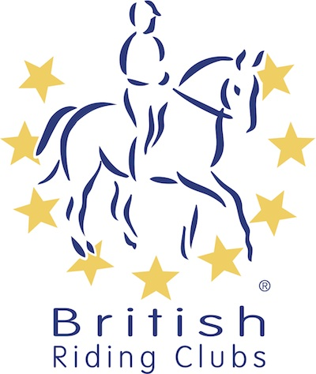
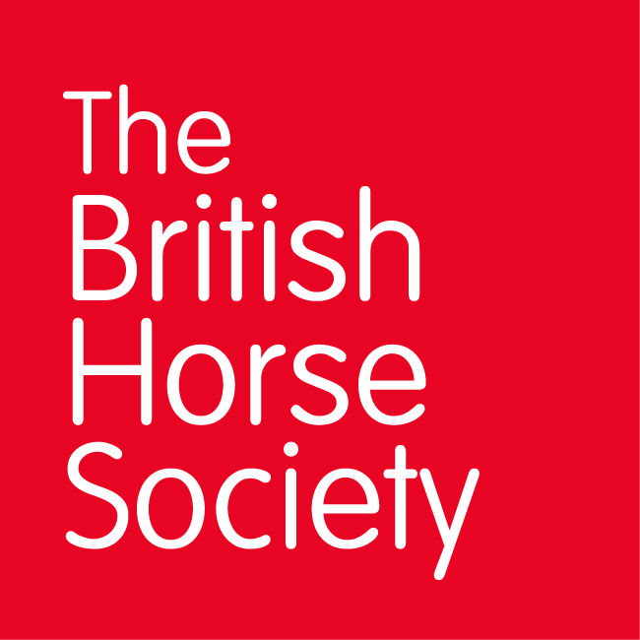
BRC CHAMPIONSHIPS 2025
AREA 21 SUMMER QUALIFIER DATES

COMPETITION | DATE | VENUE | ORGANISER | Official  Steward
National Champs (Dressage) | 24/05/2025 | Carmarthen showground | Fiona Herbert, Cwmaman RC
Combined Training | 14/06/2025 | Little Mill | Tracey Maczka, Tivyside RC
National Champs (Show Jumping) | 28/06/2025 | Beacons Equestrian Centre | Fiona Herbert, Cwmaman RC
Horse Trials (80cm, 90cm & 100cm) | 29/06/2025 | Howick Farm, Itton, NR CHEPSTOW, Monmouthshire, NP16 6BL, United Kingdom | Howick BE
Horse Trials (70cm) | 06/07/2025 | Gower | Gower RC
Combined Challenge
Closing dates for all qualifiers are 21 days before the event.
Please note qualifiers should be held at least 28 days before the Championship date.

