
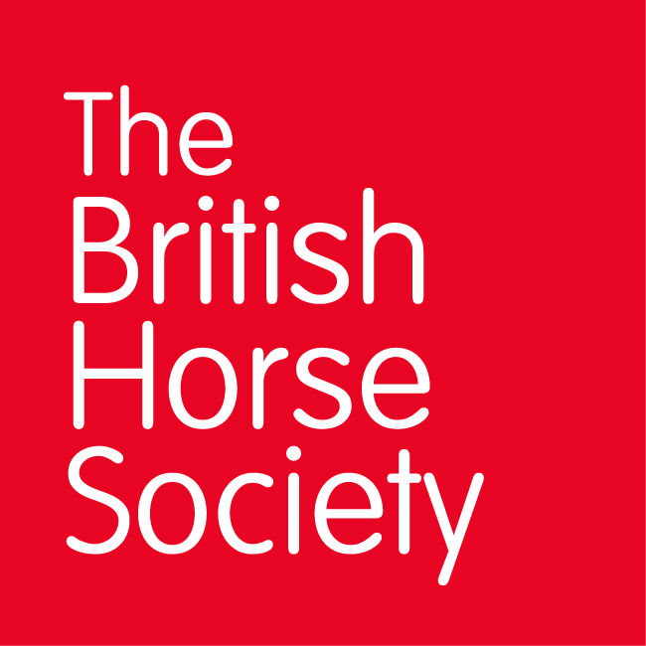
BRC CHAMPIONSHIPS 2025
AREA 2 SUMMER QUALIFIER DATES

COMPETITION | DATE | VENUE | ORGANISER | Official  Steward
Horse Trials | 15/6/25 | Ivesley Equestrian Centre. Ivesley Lane. Waterhouses. DH7 9HB | Hilary McKenna | Hilary McKenna
Dressage (Lincoln) | 29/6/25 | Ivesley Equestrian Centre. Ivesley Lane. Waterhouses. DH7 9HB | Hilary McKenna | Hilary McKenna
Show Jumping (Lincoln) | 29/6/25 | Ivesley Equestrian Centre. Ivesley Lane. Waterhouses. DH7 9HB | Hilary McKenna | Hilary McKenna
Combined Challenge | 17/08/25 | Ivesley Equestrian Centre. Ivesley Lane. Waterhouses. DH7 9HB | Hilary McKenna | Hilary McKenna
Combined Training | 17/08/25 | Ivesley Equestrian Centre. Ivesley Lane. Waterhouses. DH7 9HB | Hilary McKenna | Hilary McKenna
Closing dates for all qualifiers are 21 days before the event.
Please note qualifiers should be held at least 28 days before the Championship date.

