Gingerbread man

Please consider the types of abuse that children and adults may face and the indicators that may be associated with them.
On the inside of the gingerbread man, write any feelings and behaviours that may be associated with abuse.
On the outside of the gingerbread man, write any physical signs of abuse that you might see.
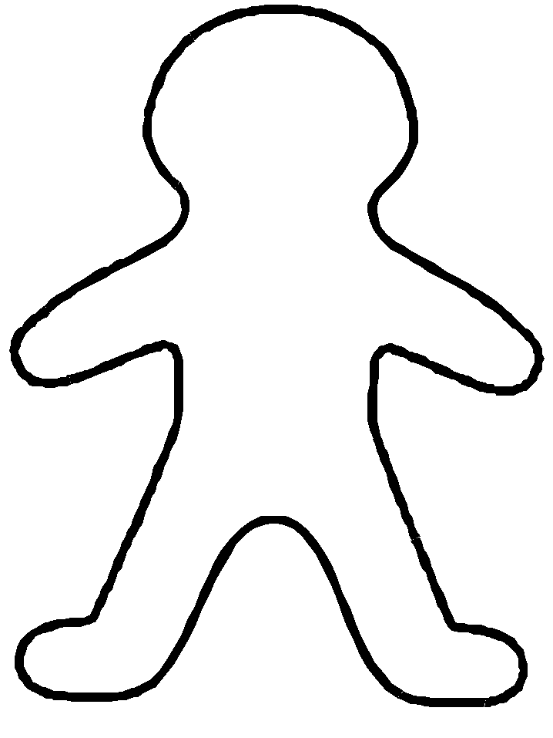

Scared
Unexplained bruising

