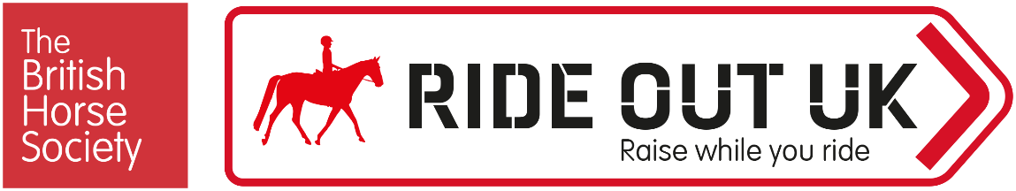

BHS Ride Out UK Event Terms and Conditions
Enter ride name, date and details here
[Select and use those which apply to your event – please read each section in full]

General
- Advance bookings are classed as those made or received before [insert time] on [insert date].
- All entrants must hold third party public liability insurance, either through being a Gold member of The British Horse Society or via proof from another provider.
- Entries on the day are by cash only.
- Online entries only, no cash will be taken on the day.
- Please report to the organisers on arrival.
- Always follow the instructions of marshals and officials.
- Registration opens at [insert time] and closes at [insert time].
- Horses may start at any time between [insert time] and [insert time].
- You will be asked to provide emergency contact details, vehicle make, model and registration on arrival.
- Everyone attending the event is responsible for ensuring the safety of themselves and others.
- The BHS, or the training venue, cannot provide supervision for attendees under the age of 18. It is a recommendation that any attendee below the age of 16 years should be accompanied by a responsible adult who remains at the venue for the duration of the course or event. For attendees aged 16-17, or an adult at risk, it is at the discretion of their parent or guardian. Accompanying adults may need to pay to attend the event, this is at the discretion of the event organiser.
- Please leave the parking area as you found it – don’t muck out your trailer or lorry in the parking area and take dung home with you.
- Dogs are permitted but MUST always be kept secured on a lead.
- Dogs are NOT permitted.

Riders
- The BHS strongly recommends wearing hi viz when riding and carriage driving.
- Hi viz clothing must be worn on the horse and rider.
- Hi viz tabards will be provided and must be worn (£5 refundable deposit required). All tabards to be returned at the end of the ride.
- Riders under 16 years must be accompanied by a responsible adult for the duration of the event.
- Riders over 16 and under 18 may ride unaccompanied at the discretion of their parent or guardian.
- Hats and body protectors (if you choose to wear a body protector) will not be checked. It is your responsibility that these are to the current standards. Please refer to www.bhs.org.uk/advice-and-information/tack-and-equipment/what-to-wear.
- Hats to the current standard must always be worn and correctly secured when mounted. Please check yours meets current standards which can be found at www.bhs.org.uk/headwear
- Body protectors are strongly recommended and should comply with current standards – also found on the BHS website at www.bhs.org.uk/body-protectors
- All riders must wear suitable riding footwear. Wellington boots and trainers are not allowed.
- Riders are advised to carry a mobile phone and be aware of the emergency contact number for the event.
- All riders must have previous experience of riding the horse they have entered into the event.
- All riders, whether they have completed the ride or not, must report their return to the organiser.
- Always ride and carriage drive with courtesy, care and consideration to fellow users of the route including equestrians, cyclists, walkers, particularly those who may be elderly, disabled, children, or simply be frightened of horses. Pass others slowly.
- If the event incorporates using a road, ensure the Highway Code is adhered to.
- Do not stray from the planned route or designated areas. Remember horses’ hooves can damage surfaces in wet weather.
- Leave gates as you find them and ride slowly past any livestock.

Horses
- All horses must be no younger than four years of age and be of an appropriate fitness level for the activity being undertaken – hooves and shoes must be in good condition.
- It is the rider’s responsibility to ensure their horse is fit and healthy enough to complete the chosen distance comfortably.
- Tack must be suitable, in safe condition and fit correctly.
- Any stallions must be informed to the organizer at the time of booking. No person may bring a stallion without ensuring always that other riders, horses and members of the public are not at risk. Stallions should be identifiable by a bridle tag and yellow tail ribbon. Any stallions deemed to be unsafe by the organiser may be directed to leave the site.
- All horses must be up to date with annual equine influenza vaccinations and must be 6 days clear from their most recent booster vaccination. Further vaccination guidance can be found using the BRC Flu Vac Checker, downloadable here. Spot checks will be made at the event.
- Horses should not be left unattended when tied to horseboxes, in the parking area or on the ride.
- It is a legal requirement to have your horses’ passport when travelling to events.

Cancellations
- Strictly no refunds, except if the event is cancelled due to unforeseen circumstances.
- No entries will be refunded without a medical or vet’s certificate.
- If the event is cancelled by the BHS, the entry fee will be refunded less the administration cost.
- If the event is cancelled by the BHS, the entry fee will be fully refunded.
- In the case of cancellation by the attendee [£ insert amount} will be retained to cover admin and booking fees.
- All British Horse Society events are checked for viability around ten working days beforehand. Any that have insufficient numbers may be cancelled. In this case, delegates who have booked will receive a full refund or free transfer should another suitable event be pending.

Online Events
- Please be aware that some events may be recorded. Images/videos will be used for general publicity including, but not limited to, the BHS website, British Horse magazine and social media. If you do not want to be seen or heard it is your responsibility to ensure your camera and microphone are turned off, however your name may still be displayed.
- For more details about how your personal data is used please take a look at our Privacy page: www.bhs.org.uk/privacy or contact dataprotection@bhs.org.uk
- Sessions will be recorded; you will be able to request a copy of the footage post event within 7 days of the event.
- The BHS does not accept any responsibility for your personal IT equipment or internet connection which may affect your ability to access this online event.
- Disclaimer -The BHS cannot be held responsible for broadband or connectivity issues experienced during these sessions.

COVID-19
- Attendees should follow the Government guidelines for their country.

