
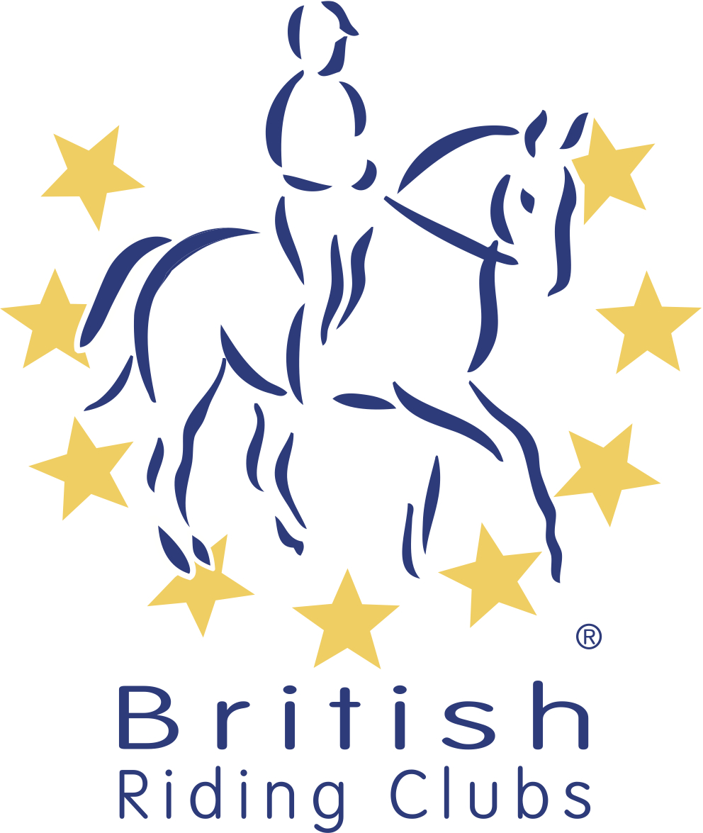
British Riding Clubs
Novice Winter Championships
Area Entry Form 2021-2022
Please use as many forms as required
CLASS | TEST | Senior (s) Junior (j) | RIDER | HORSE | MEMBERSHIP NO
Intro | Intro A
Dressage | P2
Dressage | P12
Dressage | N24
Dressage | N28
Show Jumping 70(Teams/ Individuals)
Show Jumping 80 (Teams/ Individuals)
Mixed Open 80 Show Jumping (Individuals ONLY)
RIDING CLUB
AREA
ENTRY DETAILS

CONTACT DETAILS
Name
Once completed this form must be returned to the area qualifier organiser.

Please contact the organiser for entry fees and deadlines.

I agree (on behalf of the competing member/s) to be bound by the rules of British Riding Clubs. I also understand that in the unfortunate event of cancellation, refunds will be dealt with in accordance with the current Handbook. I have checked that all horses’ flu vaccinations are correct.

It is the Team Manager’s responsibility to gain parental consent for juniors to participate at BRC events.

Signed Date
Address

Daytime Contact Number
Email

