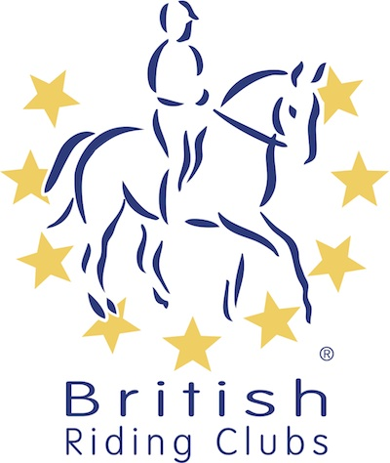
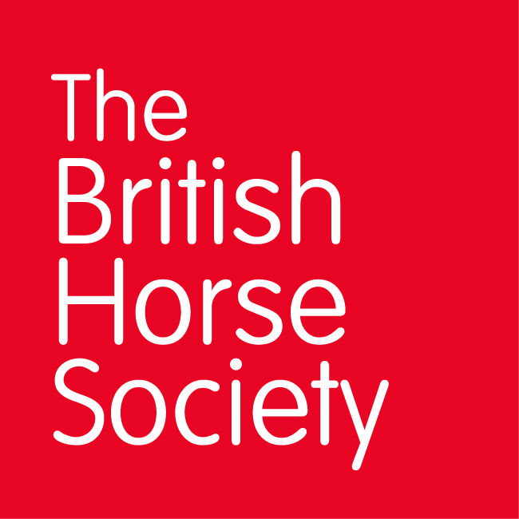
BRC CHAMPIONSHIPS 2025
AREA 9 SUMMER QUALIFIER DATES

COMPETITION | DATE | VENUE | ORGANISER | Official  Steward
National Champs (Dressage) | 14/06/2025 | Rectory Arena | Swindon RC
Horse Trials | 26/06/2025 | Howick BE, Howick Farm, Itton, NR CHEPSTOW, Monmouthshire, NP16 6BL, United Kingdom | Howick BE
National Champs (Show Jumping) | 05/07/2025 | Rectory Arena | Wessex Gold
Combined Training
Combined Challenge
Closing dates for all qualifiers are 21 days before the event.
Please note qualifiers should be held at least 28 days before the Championship date.

