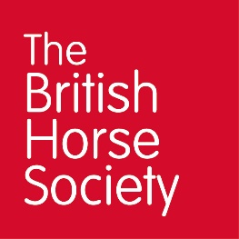
The British Horse Society
Photographer Brief
About The British Horse Society
The British Horse Society (BHS) is the largest and most influential equestrian charity in the UK. The BHS makes a positive impact on the lives of horses and horse owners with wide-ranging campaigns and initiatives. Established in 1947, we aim to protect and promote the interests of all horses and those who care about them.
Everything we do is in pursuit of our charitable objectives, which are underpinned by our core foundations of Education, Access, Welfare, Safety & Participation. Our values also play a huge part in how we are governed, with our Horse First approach, and principles of Respect, Supportiveness and Excellence as well as our One Team collaboration, at the heart of everything we do.
Read more about our objectives & values here.
Our thriving and active community of horse lovers, members, supporters, volunteers and partners are committed to improving the lives of horses everywhere. Our local activity helps us to engage with and grow this community.

Photography used by The British Horse Society
Many people around the world look to the BHS for best practice on all things equine. It is very important that any image we use represents us as a trusted organisation. Photographs need to show:
- Horse & riders happy and in harmony with safe and correct fitting equipment.
- Mounted combinations must be suitably sized.
- Healthy horses, appearing relaxed and not distressed.
- Stabled horses looking content, well cared for and healthy.
- People enjoying their time with each other.
- The unique bond and partnership between horse and rider.
Full image guidelines for local events can be found here.

General publicity
An agreed set of photos donated by you to the BHS may be used by the BHS in printed, online or electronic publications, which may be shared publicly. Examples of these materials include, but are not limited to posters, leaflets, brochures, adverts, emails, e-newsletters, blogs, web pages, social media posts, presentations, speeches, research or policy reports and press releases or other materials.

Thank you for supporting the BHS.

