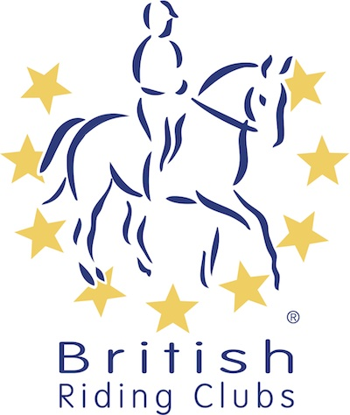
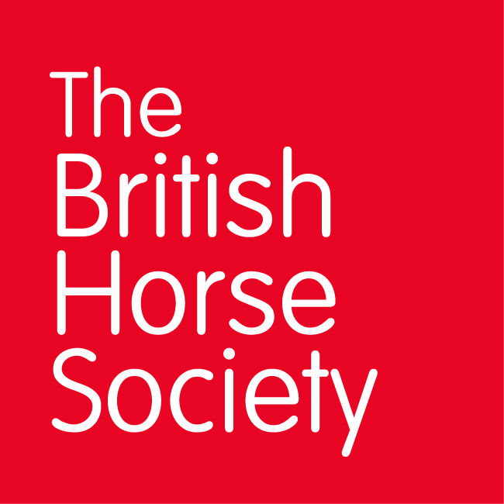
BRC CHAMPIONSHIPS 2025
AREA 18 SUMMER QUALIFIER DATES

COMPETITION | DATE | VENUE | ORGANISER | Official  Steward
National Champs | 12/04/2025 | Lincomb Equestrian, Lincomb, Worcestershire, DY13 9RB | Worcester, Alison Harris | Chris Esling
Combined Challenge | 04/05/2025 | Solihull Riding Club, Four Ashes Road Bentley Heath, Solihull B93 8QE | Tony Parker (joining area 5) | Chris Esling
Horse Trials | 08/06/2025 | Lybrook Farm, Broadway, WR12 7JS | Camilla Esling
National Champs | 06/07/2025 | Hoden Lane, Cleeve Prior, WR11 4LH | Cropthorne & Evesham Vale RC Julia Tyrrell | Camilla Esling
Combined Training
Closing dates for all qualifiers are 21 days before the event.
Please note qualifiers should be held at least 28 days before the Championship date.

