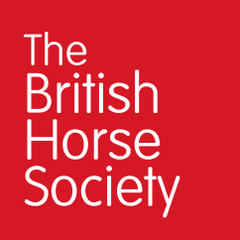

The British Horse Society is a Registered Charity Nos. 210504 and SC038516