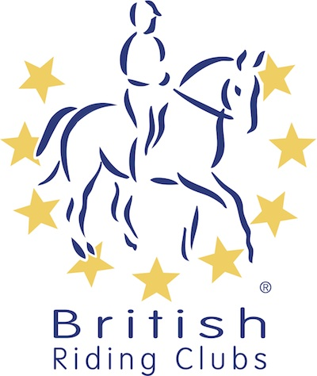
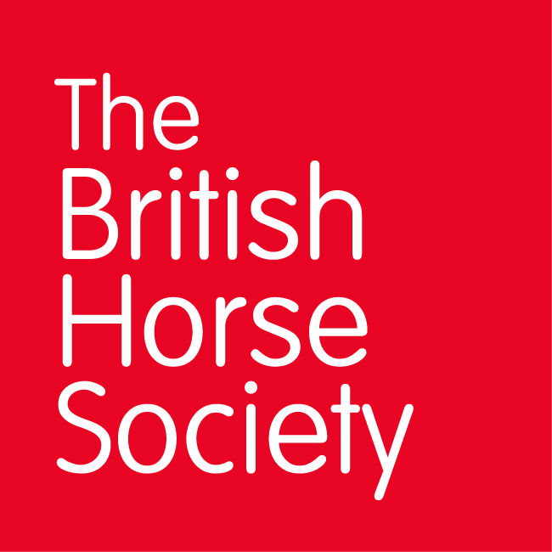
BRC CHAMPIONSHIPS 2025
AREA 17 SUMMER QUALIFIER DATES

COMPETITION | DATE | VENUE | ORGANISER | Official  Steward
Horse Trials | 08/06/2025 | Moreton Equestrian Centre, Moreton Stables, Dorchester DT2 8RG | Moreton-Russell & Purbeck RC, Sue Russell | Bob Mael
National Champs (Dressage) | 14/06/2025 | Wood Farm Equestrian Bramdean, Alresford Hampshire SO24 OJH | Meon RC, Corinne Staples | Penny Towers
Combined Challenge | 29/06/2025 | Moreton Equestrian Centre, Moreton Stables, Dorchester DT2 8RG | Moreton-Russell & Purbeck RC
National Champs (Show Jumping) | 19/07/2025 |  | Purbeck RC
Combined Training | 10/08/2025 | Sparsholt College, Westley Lane, Sparsholt SO21 2NF | New Forest RC
Closing dates for all qualifiers are 21 days before the event.
Please note qualifiers should be held at least 28 days before the Championship date.

