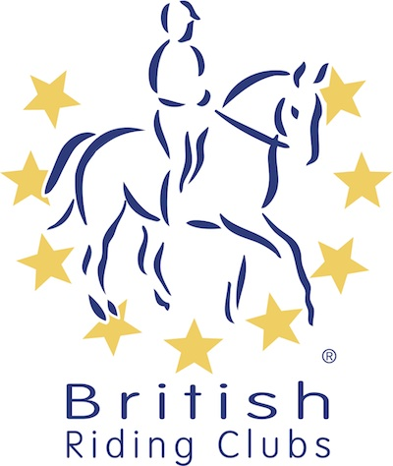
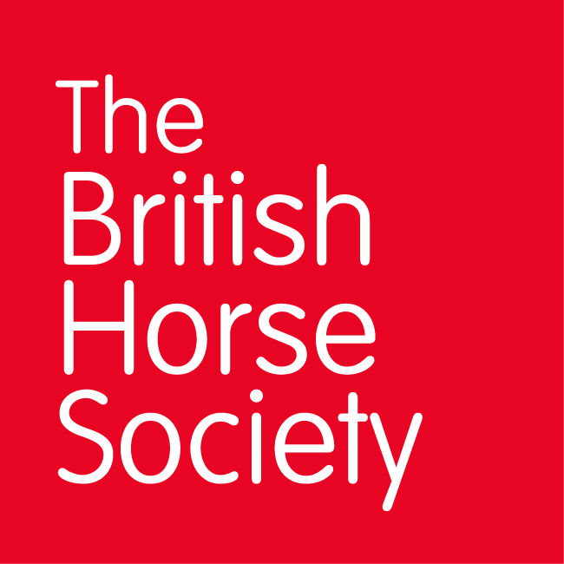
BRC CHAMPIONSHIPS 2025
AREA 11 SUMMER QUALIFIER DATES

COMPETITION | DATE | VENUE | ORGANISER | Official  Steward
Combined Challenge | 29/03/2025 | Tweseldown Equestrian Centre, Bourley Rd, Church Crookham, Fleet GU52 8AD | Tweseldown Racecourse | Cathy Hughes
Horse Trials | 08/06/2025 | Munstead Horse Trials, Heath Lane, Godalming, Surrey, GY7 1UN | Munstead Horse Trials | Caroline Moorey
National Champs (Show Jumping) | 15/06/2025 | Munstead Horse Trials, Heath Lane, Godalming, Surrey, GY7 1UN | Elstead RC Penny Jann | Cathy Hughes
National Champs (Dressage) | 15/06/2025 | Munstead Horse Trials, Heath Lane, Godalming, Surrey, GY7 1UN | Jackie Russell | Cathy Hughes
Combined Training | 29/06/2025 | Felbridge Show Ground, Copthorne Rd RH19 2NU | Caroline Exley (joining Area 13) | Jenny D’Entremont
Closing dates for all qualifiers are 21 days before the event.
Please note qualifiers should be held at least 28 days before the Championship date.

