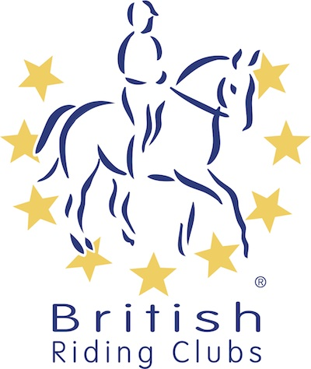
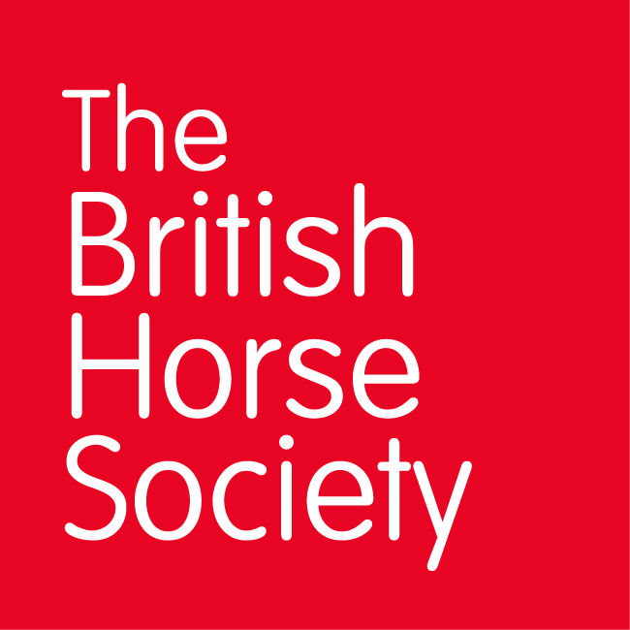
BRC CHAMPIONSHIPS 2025
AREA 15 SUMMER QUALIFIER DATES

COMPETITION | DATE | VENUE | ORGANISER | Official  Steward
Combined Training | 15/06/2025 | TREMAINS FARM, LANMAES RD, LLANMAES, LLANTWIT MAJOR, Vale Of Glamorgan, CF61 2XF | Llantwit Major & District RC, Ann Barnaby | Mair Jones
Horse Trials | 29/06/2025 | Howick Farm, Chepstow, NP16 6BL | Southerndown RC, Mair Jones | Jenny Thomas
National Champs (Dressage) | 13/07/2025 | USK SHOWGROUND, CHEPSTOW RD GWERNESNEY, USK NP15 1ES | Wye Valley RC, Janet Peters | Mair Jones
National Champs (Show Jumping) | 19/07/2025 | ABERHALL ARENA, ST OWENS CROSS, HEREFORD, HR28LL | Hereford & District RC, Beth Crozier | Jenny Thomas
Combined Challenge
Closing dates for all qualifiers are 21 days before the event.
Please note qualifiers should be held at least 28 days before the Championship date.

