
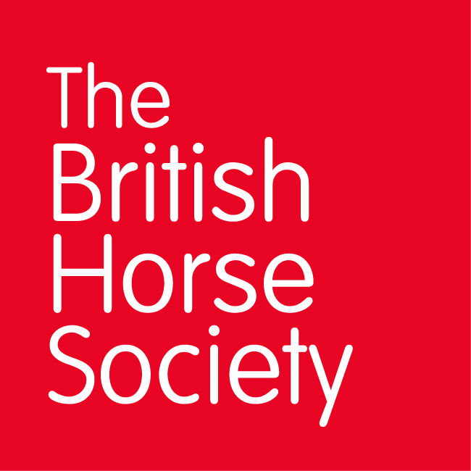
BRC CHAMPIONSHIPS 2025
AREA 3 SUMMER QUALIFIER DATES

COMPETITION | DATE | VENUE | ORGANISER | Official  Steward
Horse Trials | 05/7/25 | Smallwood Livery Centre, Brookhouse Farm, Brookhouse Green CW11 2XE | Chris Walton | Hilary Secker
Dressage (Lincoln) | 21/6/25 | Bold Heath Equestrian Centre, Warrington Road, Widnes, Cheshire, WA8 3XT | Penny Ridley
Show Jumping (Lincoln) | 26/7/25 | Bold Heath Equestrian Centre, Warrington Road, Widnes, Cheshire, WA8 3XT | Alison Geary | Hilary Secker
Combined Challenge | 10/5/25 | Bold Heath Equestrian Centre, Warrington Road, Widnes, Cheshire, WA8 3XT | Alison Geary | Hilary Secker
Combined Training | 10/05/25 | Bold Heath Equestrian Centre, Warrington Road, Widnes, Cheshire, WA8 3XT | Alison Geary | Hilary Secker
Closing dates for all qualifiers are 21 days before the event.
Please note qualifiers should be held at least 28 days before the Championship date.

