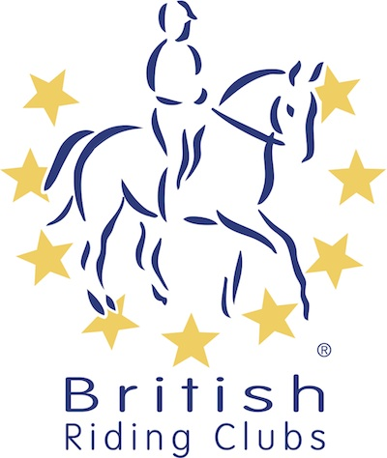
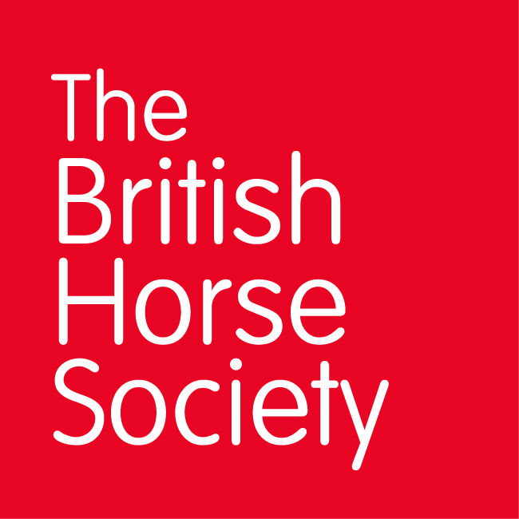
AREA (15) SUMMER QUALIFIER DATES 2025

COMPETITION | DATE | VENUE | ORGANISER | OFFICIAL STEWARD
COMBINED TRAINING | SUNDAY  15TH JUNE 2025 | TREMAINS FARM, LANMAES RD, LLANMAES, LLANTWIT MAJOR | LLANTWIT MAJOR & DISTRICT RC  ANN BARNABY  ann.barnaby@btinternet.com | MAIR JONES  nagline@yahoo.co.uk
HORSE TRIALS | SUNDAY  29TH JUNE 2025 | HOWICK FARM  CHEPSTOW  NP16 6BL | MAIR JONES  nagline@yahoo.co.uk | JENNY THOMAS
SUMMER DRESSAGE | SUNDAY  13TH JULY 2025 | USK SHOWGROUND  CHEPSTOW RD GWERNESNEY, USK NP15 1ES | JANET PETERS  wyevalleyriding@gmail.com, | MAIR JONES  nagline@yahoo.co.uk
SUMMER SHOW-JUMPING | SATURDAY  9TH AUGUST 2025 | USK COLLEGE  USK  NP15 1XJ | SARAH CANNING  Sarah.clytha@gmail.com | JENNY THOMAS

Closing dates for all qualifiers are 21 days before the event.
Please note qualifiers should be held at least 28 days before the Championship date.

