
Generic Risk Assessment
Activity Assessed: Manual Handling Name of the Assessor: Samar Chakraborty
Date of review: 24/12/2025 Date of next review: 23/12/2026
Hazards | Who might be harmed and How might they be harmed? | Current Control Methods  (What are you already doing to control this risk?) | Further control measures  (Do you need to do anything else to control this risk?) | Who is responsible to carry out the actions? | Action by when? | Date of completion.
Environment | Employees, volunteers and participants are at risk of slips, trips, and falls due to wet or slippery floors, struck by a fixed object, stable fixtures, or doors, when handling equipment and where horse involved are at risk of falling due to being kicked or bitten by horses. | Ensure that there are no trip hazards at any time and that all flooring is flat when handling equipment  Hazards such as wet or contaminated surfaces, trailing cable, blocked access, etc. would be addressed to eliminate slips and trips hazards prior to handle equipment.  The stable area is kept free from hazards such as mud, manure, urine, or any other potential trip hazards.  Regular cleaning and maintenance to ensure a safe working environment. | Contractor to install levelled flooring and ensure all cables are secure. | The Organiser/ Employees/volunteers
Use of Contractors | Employees, volunteers and visitors may suffer risks of injury due to inappropriate manual handling practices followed by the contractors. | Ensure contractors are competent and follow the event risk assessment and safety procedures when handling equipment  The BHS Health and Safety policy documents delineated both the contractor’s and the organisation’s responsibility to ensure a safe system of work. | The organisers ensure that the contractor’s emergency contact details are up to date. | Contractors/ Organiser/ Employees/volunteers
Employees/Volunteers | All(mentioned above) may suffer back injury or carpal tunnel syndrome from inappropriate lifting or handling of items. | The organisers ensure that those involved in manual handling follow safe lifting procedures and intervene if any unsafe practices are observed. They also ensure that weights are suitable for safe lifting.  Stock and equipment will be transported by a contractor to ensure minimal heavy lifting is necessary.  Staffs/Volunteers are advised to avoid manual handling  If manual handling cannot be avoided, ensure the team used handling aids.  Volunteer are advised to take adequate break to avoid repetitive work  Ensure volunteers are provided with event information, contact numbers, role description and instructions before the event. | Staff and volunteers required to handle heavy items must receive manual handling training. | Organiser/ Employees/volunteers
Events | Employees/volunteer may suffer back injury or carpal tunnel syndrome from inappropriate lifting or handling of items. | Staffs/Volunteers should be adhered to the venues fire safety, exits and evacuation procedures and fire exits should not be blocked at any times.  Employees/volunteers cannot handle fire equipment such as fire extinguishers, gas cylinders without given proper manual handling training and safety instructions where needed.  Poles and other heavy sports equipment should only be handled by adults with appropriate training.  Avoid manual handling where possible; however, if it cannot be avoided, use handling aids, split loads into smaller parts, and seek assistance from others  Volunteers attending bridleway clearances and Welfare concerns follow the manual handling procedures and the bridleway clearance risk assessment. | Follow the event risk assessment for further information | Organiser/ Employees/volunteers
Offices | Employees, visitors, volunteers Employees/volunteer may suffer back injury or carpal tunnel syndrome from inappropriate lifting or handling of items. | When storing of folders & boxes in tall and lower cabinets, use of steps, working in pairs, heavier items stored at mid torso range & general manual handling instruction on new induction DVD.  When moving large or heavy boxes/parcels in the post room, use sack trucks and cages. Reduce the amount to be moved in these areas by arranging direct delivery to the recipient by courier, collection by the recipient, or using fulfilment/storage facilities.  Movement of large/heavy boxes/parcels in BHS offices, use sack trucks and cages when moving items. Reduce the amount to be moved in these areas by arranging direct delivery to the recipient by courier or by using fulfilment/storage facilities | Inform employees in advance if any large-scale manual handling will be carried out in the post room or in the office for awareness purposes. | Employees/Volunteers/ Contractors
Adverse weather | Employees or volunteers may suffer mild to severe health issues if they continue working outdoors in extreme temperatures | For outdoor work activities, all persons will be advised to wear clothing appropriate to the weather conditions.  Consider extreme heat or cold temperature, take appropriate cautions and cancel or reschedule the event if required  Advise staffs/volunteers to keep them warm in freezing temperature, wear appropriate cloth and have hot drinks | Monitor the weather condition prior to and on the day of event. | Organiser/ Employees/volunteers
Welfare Van | Employees/ Volunteers Employees/volunteer may suffer back injury or carpal tunnel syndrome from inappropriate lifting or handling of items. | Staffs/volunteers handling Weighbridge follow the weighbridge standard procedures.  People are involved in loading and unloading vans/cars for equipment required at events/external receive regular manual handling training | Follow the checklist and guidance note below for further information | Employees/ volunteers
Stand Set Up | Employees/ Volunteers/ Maintenance Staff Employees/volunteer may suffer back injury or carpal tunnel syndrome from inappropriate lifting or handling of items. | People are involved to set up stands must have training on manual handling.  Stand will be installed and checked by a competent contractor.  Marquee is securely erected and strong enough to withstand against extreme wind or rain.  Method statement is followed to erect the stand or marquee.  Larger equipment and electrical sockets will be kept behind the scenes to avoid interfering with activities and members of the public. | Follow the Marquee Fire Risk Checklist available on the H&S site in SharePoint. | Contractors/ Organiser/ Employees/volunteers
Staffing | Volunteers and Staff Employees/volunteer may suffer back injury or carpal tunnel syndrome from continuous lifting or handling of items without adequate break. | Ensure sufficient lunch and rest breaks are given throughout the day and worked into the staff rota. | Offer accommodation to anyone traveling more than three hours to the show where applicable. | Organisers
Lone working | Staff /volunteers | Lone workers will not be encouraged involved in manual handling.  BHS staff/volunteer receives lone working training if involved in manual handling  Maintain an effective communication with line manager/appropriate channel. | Follow the BHS lone working policy to minimise risk from lone working. | Organiser/ Employees/volunteers
PPE | Staff/ Volunteers | Staffs/volunteers wear appropriate PPE, such as gloves, helmet, Hi-Viz, safety shoes where necessary when handling heavy equipment | Use mask where needed. | Organiser/ Employees/volunteers

Manual Handling Checklist
This form need only be completed for tasks that have been identified by the filtering process in Part 1 as presenting a significant risk and cannot be easily eliminated. Please refer to Part 3 - Further Information for guideline figures for lifting and lowering.
Task Covered by This Assessment: | Loading van/car with items for transportation. Setting up of stalls, clinics, photoshoots and shows at external events. Stock, fencing, tables and other equipment set up after unloading from a van. Pack up at the end of event and probably reloading a van for transportation.
Categories of Personnel Involved: | Approvals, Welfare, BRC, Education, Merchandising, Marketing, Regional Officers and Volunteers (all departments). All staff levels.

Questions to Consider: | If Yes Tick  Appropriate Level of Risk |  |  | Problems Occurring from the Task: | Possible Remedial Action Required:
Questions to Consider: | Low | Med | High | Problems Occurring from the Task: | Possible Remedial Action Required:
Do the tasks involve:
Holding loads away from the trunk? |  | ✓ |  | Musculoskeletal injury | Holding load for short time and carry load for short distance. TILE method should apply
Twisting? |  |  |  | Musculoskeletal injury | Working in pairs, lessening amount/weight of items carried, use of a packing/set up company and specific manual handling training for all those exposed to these tasks.
Stooping? |  |  |  | As above | As above
Reaching upwards? |  |  |  | Falls from height | By mechanical means or using ladders. Tile methods apply
Large vertical movements? |  |  | ✓ | Collapse of items/substances may cause severe bodily injury to death. | Carry the load by mechanical aids such as hoists. LOLER regulations apply.
Carrying long distances? |  |  |  | Musculoskeletal injury | Use of mechanical aids – cages, sack trucks etc. Lessen weight and increase breaks.
Strenuous pushing and pulling? |  |  |  | Musculoskeletal injury and Carpal tunnel syndrome | Use of mechanical aids – cages, sack trucks etc. Lessen weight and increase breaks.
Unpredictable movement of loads? |  |  | ✓ | As above plus crushing or collapse of items. | Use of mechanical aids – cages, sack trucks etc. Secure loads correctly.
Repetitive handling? |  | ✓ |  | Carpal tunnel syndrome | Adequate break, avoid manual handling, if possible, Use of mechanical aids such as sack trucks
Insufficient time for rest or recovery? |  | ✓ |  | Impact physical and mental health | Planning work, allow adequate time to complete task and allow break
A work rate imposed by the process?
Are the loads:
Heavy? |  |  |  | Musculoskeletal injury plus crushing issues if dropped | Avoid manual handling. Use of mechanical aids – cages, sack trucks etc. Lessen weight and increase breaks.
Bulky/unwieldy? |  |  |  | As above if mishandled | Avoid manual handling. Use mechanical aids – cages, sack trucks etc.
Difficult to grip? |  |  |  | As above if dropped | TILE method apply. Use mechanical aids – cages, sack trucks etc. Lift in greater numbers.
Unstable/unpredictable? |  |  |  | As above if size/bulk of some items causes this | TILE method applies. Use of mechanical aids – cages, sack trucks etc. Lessen weight, increase breaks and numbers lifting.
Does the working environment have?
Poor posture? |  | ✓ |  | Body aches and pains including upper or lower back pain, neck, shoulder and arm pain, mental stress | Balanced upright posture, with a straight line from the ear to the shoulder to the hip
Poor floors? |  |  |  | Decrease in stability when carrying loads which could lead to dropping and crush, back or other muscle injuries | Cautions using of mechanical aids – cages, sack trucks etc, to avoid trip. Use of matting or boards.
Variations in levels? |  |  |  | As above | As above plus use of suitably wheeled mechanical aids – lifts, cages, sack trucks etc. Take variations in smaller stages at angles with less weight.
Hot and cold humid conditions? |  |  |  | Heat stress and shivering, slippery surfaces | Avoid adverse weather conditions. Use of suitably wheeled mechanical aids – cages, sack trucks etc. Lessen weight and increase breaks.
Strong air movements? |  |  |  | Unstable movement of items cause slip or trips. | Avoid adverse weather conditions, use of mechanical aids – cages, sack trucks etc. Lessen weight, height and increase breaks.
Poor lighting? |  |  |  | Recognition of surface changes and conditions could be hindered resulting in an increase in the risk of trips, slips and falls. Same injuries from carrying loads as above | Ensure adequate lighting or stop working where not possible. Use of mechanical aids – cages, sack trucks etc. plus increase lighting source in dimly lit areas.
Individual capability:
Does the job:
Require unusual capability? |  |  |  | Increased strength and manoeuvrability may be required with heavy/awkward loads. Crush, back or other muscle injuries | Tile method applies. Use of mechanical aids – cages, sack trucks etc. Lessen weight and increase breaks.
Present a hazard to those with a health problem? |  |  |  | Increased risk to those with previous injuries, ill health or disability of injuries above | Individuals with health problems should discourage taking part in handling operation.
Present an additional hazard to those who are pregnant? |  |  |  | Increased risk of injuries above and complications with pregnancy for any load movement especially heavy/awkward types | Individuals with such conditions are advised to avoid any types of manual handling.
Require special information and training? |  |  |  | Without any knowledge of how to move items correctly an increased risk of the injuries above will be prevalent | Adequate training prior to start manual handling is advisable. Use of mechanical aids – cages, sack trucks etc. Lessen weight and increase breaks whilst giving prior training. Specific manual handling training for all those exposed to these tasks.
Other factors:
Is movement or posture hindered by clothing or PPE? |  |  |  | Slips or trips | Appropriate clothing

Manual Handling Risk Assessment Part 3 – Further Information
The following are officially accepted guideline figures; below these levels 95% of people should not be at significant risk.
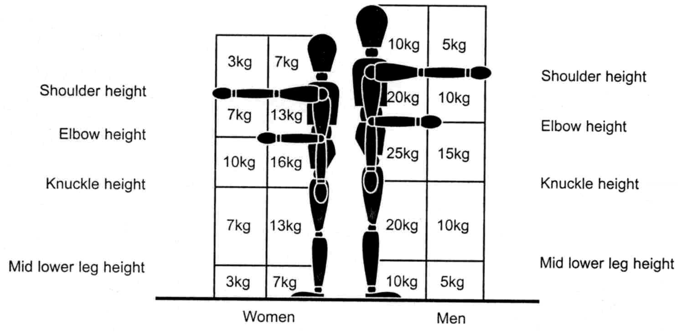
- These values should be further reduced by 20% if the job requires twisting at the waist.

- If the task is repeated twice/minute the value should be reduced by 30%.
- If the task is repeated twelve times/minute the value should be reduced by 80%.

Examples/Clarification

Question | Example/Clarification
The Task  - Holding away from the body | - Loading the back of deep racking
- Stooping forward | - Where it is not possible to bend knees i.e. putting material into the boot of a car
- Excessive lifting distances | - From floor to above head height
- Frequent repetitive handling | - More than 30 times per hour
The Loads  - Heavy outside the guideline figure | - Refer to the chart, the more the guideline figure is exceeded the greater the risk
The Work Area  - Extremes of temperature | - Likely to apply, to outdoor work and work in cold stores and foundries etc.
Individual Capability  - Present a hazard to those with a health problem. | - i.e. those with disability or previous injury

nagement Team in consultation with the event Health & Safety Advisor.

