BHS Social Media Guidelines
March 2018

These guidelines are designed for anyone running or assisting with British Horse Society social media accounts in their nation, county, region or department.
These guidelines are in addition to related documents, including the social media policy within the employee handbook and image guidelines.
Contents
- Introduction
- Best practice
2.1. Content
2.2. Images
2.3. Competitions
2.4. Groups
2.5 Account information
2.6. Account ownership & administration
2.7. Monitoring, responding & dealing with negative comments
3. Contact details for help
- Introduction
Social media is a great platform to share information on a range of topics, post updates and photos from related activities and events. The main benefit of social media is it allows you to engage and connect with your followers on a more informal level, both publicly in comments and privately in direct messages.
Our aim with these guidelines is to ensure all British Horse Society social media accounts and their content meets standard regulation guidelines and to see where we can improve the engagement and connection with our members and followers.
We are also aiming to provide all of our members and followers with a consistent, enjoyable and easily-accessible experience across all of our social media presence.
If you cannot commit to any of the following guidelines, please contact the Digital Communications team at webmaster@bhs.org.uk and we will advise you on next steps.

- Best Practice
 | Facebook | Twitter
Character length | Keep under 400 characters so all content visible, but aim to be as concise as possible | Keep between 120-130 characters for optimum engagement
Video length | Keep video content 90 seconds or less for optimum engagement (30 seconds ideal) | Keep video content 90 seconds or less for optimum engagement
Tone of voice | Conversational and approachable | Succinct and topical content
Link with website | Link to BHS website wherever possible with the most relevant link (become a member, find a place to ride, book this event etc…) | Drive people to the BHS website with the most relevant link (read news article, find out more etc…)

2.1 Content
Posting on social media should be regular. We recommend at least once a week and no more than once a day. The BHS uses social media for:
- Brand management:
  - Protect and promote our brand as the UK’s leading equestrian charity
  - Drive readers to relevant content on our website
  - Build our membership and supporters
- Engagement
  - Engage and socialise with members and supporters, showing an active interest in and empathy with their varied equestrian lifestyles and aspirations.
  - Informal engagement with users, e.g. sharing member photos or asking what they did with their horses at the weekend.
- Promotion:
  - Upcoming BHS events
  - Events at BHS Approved Centres
  - Courses held by BHS Accredited Professional Coaches
  - BHS jobs and volunteering opportunities
- Awareness and information
  - Latest news published on the BHS site
  - Topical and relevant information about all of our areas of work and activity (Safety, Education, Welfare, Access etc.)
  - Raising funds and awareness of our work
2.2 Images
Images should also be compliant with the ‘Image Guidance’ document that has been shared by the marketing team. We must not post images or videos without written permission from the person who owns the content, as well as getting consent for any persons depicted in the image or video.
Please note with changes in GDPR an updated policy will be provided in due course.
2.3 Competitions
Social media competitions are a great way to build brand awareness and engage our members and followers.
However, it is important that all competitions have comprehensive and compliant terms and conditions, which need to be made easily accessible to entrants. Failing to provide these could result in legal implications.
If you have an idea for a competition you would like to run on your BHS social media account, please email the Digital Communications team at webmaster@bhs.org.uk.
Dependent on time and resource, the digital team at HQ can then advise you on how to proceed and help you to provide the correct and appropriate terms and conditions.
2.4 Groups
If you have an open/public group for your region or department, we would recommend making it a closed access group or closing it down. All public updates should be covered by your regional or departmental Facebook Page and duplicating the content would be confusing for followers and members.
If you have a closed group, please make sure that the most relevant BHS representatives have access to it.
If you are unsure on how to proceed with this please contact the Digital Communications team at webmaster@bhs.org.uk.
2.5 Account Information
Naming Convention
To help our members and followers search for your social media presence easily, all BHS accounts should be named ‘BHS’ followed by the relevant region/county/ department. This is necessary for brand consistency and familiarity.
Example:
BHS Stareton
The BHS Stareton
British Horse Society Stareton
The British Horse Society Stareton
Stareton British Horse Society
Stareton BHS
bhs stareton
british horse society stareton

Profile image and cover photo
Your profile photo must be the latest version of the BHS logo.
Your cover photo must be the same as the official ‘British Horse Society’ Facebook page and Twitter page.
The most up to date version of these images will be saved in: \\sol\shared\Development Team\Marketing & Communications hub\Social media
2.6 Account Ownership and Administration
In an instance where a social page has a critical issue, it is important that we are able to gain access and resolve any issues quickly. For example if an account is hacked, or if there is an urgent emergency that needs responding to.
To reduce the risk of any PR or brand image crisis, please make your National Managers / Regional Managers and the Digital Communications team at HQ are kept up-to-date on which people have access to a page or account.
- When a Facebook Page is managed by a member(s) of the committee, the relevant National Manager / Regional Manager must be set as an Admin
- When a Twitter account is managed by a member(s) of the committee, the relevant National Manager / Regional Manager must be given the password to the account and be kept informed of any changes to the account
- Passwords should never be given out to anyone except National Managers / Regional Managers or the BHS Marketing and Communications team
- Please never use any personal Facebook, Twitter or other accounts to post as a BHS representative. This includes content anywhere on any social media, whether on BHS pages or not as per guidelines in the employee handbook
All BHS Facebook pages should grant webmaster@bhs.org.uk admin access. This ensures that the Digital Communications team can provide support quickly and easily if necessary.
If you have any problems setting this up, please email webmaster@bhs.org.uk for assistance.
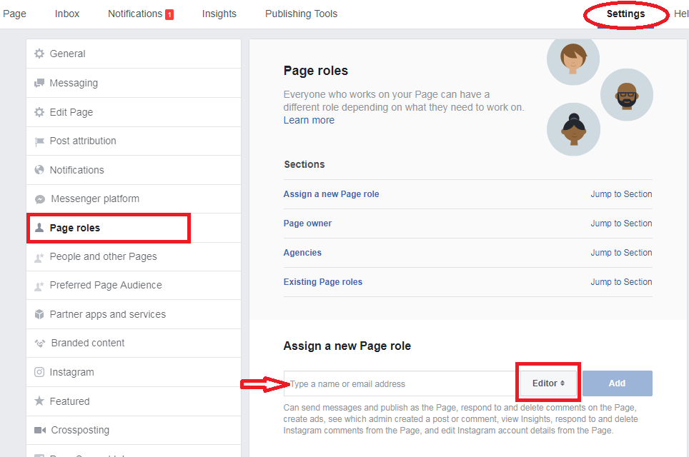
Assigning page roles

- Go to settings in the top right corner of your Facebook page
- Click the Page roles option from the left hand side
- Type in the email address of the contact you would like to assign a role, in this instance webmaster@bhs.org.uk
- Select admin from the drop down section and add
2.7 Monitoring, Responding & Dealing with Negative Comments
Responding
When responding to comments, messages and tweets, it is important to be:
- Prompt: respond to direct messages and any public queries within 48 hours, and apologise for the delay if there’s a significant wait.
- Precise: if you’re unsure of an answer or response (e.g. an exam syllabus query), please check with your National Manager / Regional Manager or colleagues at HQ. Teams are aware of the urgent nature of public requests and will do their best to help as soon as possible.
- Professional: please be mindful of spelling, grammar and BHS house style, particularly avoiding the use of all-caps (this looks like shouting) and multiple exclamation marks.
Monitoring
We recognise and appreciate that Committee members give up valuable free time to help run social media on behalf of the BHS. Ideally, accounts should at least be quickly checked each working day for new posts/mentions, comments or messages.
- Attentive: we acknowledge both positive and negative content, right down to liking positive Facebook posts that require no other response.
- Transparent: we operate an open culture and do not remove negative or complaining content unless it meets the ‘unacceptable use of social media’ criteria below
- Moderated: there is certain content we dissociate ourselves from to uphold our duty of care to our brand and other users. If necessary, post deletion or banning users from a Page (only in very rare cases).
Complaints
If you receive a complaint about a piece of content posted on your Page or Twitter account please firstly re-examine the content to see if the complaint is valid.
On Facebook, you can hide the content if necessary while seeking resolution with your National Manager / Regional Manager or the Communications team.
Once a decision is reached, please explain the decision to the complainant via the same method in which they contacted you (if a complaint is made publicly but the response is of a sensitive nature, it’s acceptable to publicly acknowledge the complaint and state we’ll respond to it privately so other users know it’s being dealt with and the complainant knows to look out for a private message).
If someone posts an inaccurate statement that could mislead others, it’s ok to post a clarification.
It is important to never be drawn into arguments between users. If these develop, users should be invited to discuss the issue privately between them. If a situation escalates into ‘unacceptable’ content, posts can be removed.
Unacceptable use of social media
We don’t allow the following content to be associated with our social media or the BHS. Please hide or remove content where necessary.
- Obscene language – we expect all language to be appropriate for junior members and we do delete
- Trolling, bullying or posts of a sexist, racist, homophobic or otherwise discriminatory nature
- Defamatory content
- Advertising or promotional posts except by APCs, Registered Grooms, Approved Establishments, Trade Members or Independent Partners.
- Content that infringes on intellectual property or privacy rights of others. We must not post content (photos/videos) without written permission from the person who owns the photo or video as well as any persons depicted in the photo or video. (Please note that this will be updated in due course in line with GDPR changes)
- Create or transmit any material that might be defamatory or incur liability for the BHS
- Post messages, status updates, or links to material that is inappropriate
  - Inappropriate content includes: pornography, racial or religious slurs, gender-specific comments, information discussing criminal skills or terrorism, or materials referring to cults, gambling or illegal drugs. This definition of inappropriate content also covers any text, images or other media that could offend someone on the basis of race, gender, age, religious or political beliefs, national origin, disability, sexual orientation, or any other characteristic protected by law.
- Use social media for any illegal or criminal activity
- Send offensive or harassing material to others via social media
- Send or post any materials which could be damaging for the company’s reputation
- Discuss colleagues, competitors, customers or suppliers without their approval
- Post, upload, forward or link to spam, junk or chain emails and/or messages
3. Contact details for help
Requesting a new account
The creation of new social media accounts in the company’s name must not be created unless approved by the Digital Communications Manager. Please send any social media account requests to webmaster@bhs.org.uk
Contact and training
In addition to your National Manager / Regional Manager, the Communications team are always available to provide guidance and support. If you require any further help with your social media account, please use webmaster@bhs.org.uk and the relevant person will be in touch with you in due course.
More News/Events

