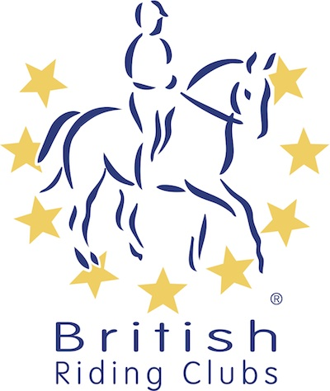
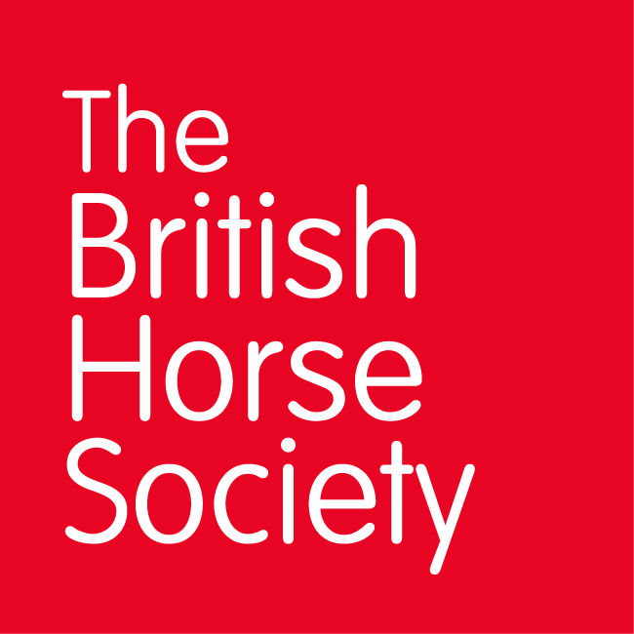
BRC CHAMPIONSHIPS 2025
AREA 22 SUMMER QUALIFIER DATES

COMPETITION | DATE | VENUE | ORGANISER | Official  Steward
National Champs (Dressage) | 07/06/2025 | Auchlishie Eventing Ltd, Auchlishie Farm, Kirriemuir, Uk DD8 4LS
Combined Training | 07/06/2025 | Auchlishie Eventing Ltd, Auchlishie Farm, Kirriemuir, Uk DD8 4LS
National Champs (Show Jumping) | 07/06/2025 | Auchlishie Eventing Ltd, Auchlishie Farm, Kirriemuir, Uk DD8 4LS
Horse Trials | 08/06/2025 | Auchlishie Eventing Ltd, Auchlishie Farm, Kirriemuir, Uk DD8 4LS
Combined Challenge |  |  | Not Running | Not Running
Closing dates for all qualifiers are 21 days before the event.
Please note qualifiers should be held at least 28 days before the Championship date.

