The British Horse Society: Code of Conduct for Welfare of Horses at Events and Activities
Date last reviewed 11 June 2025

This code of conduct should be interpreted by participants in the spirit of integrity, transparency and common sense. Breaches of the code of conduct may result in disqualification from an event or activity. This code of conduct covers the following:

- Welfare of the Pony/Horse
  - Examples of poor welfare
  - Health and hygiene
  - Vaccinations
  - Transporting horses
  - Welfare recommendations
  - Exercising
  - PPE
  - Equipment
- Conduct of participants, volunteers, officials and representatives
- Safeguarding
- Useful Contacts

1: WELFARE OF THE PONY/HORSE

Our vision and purpose is for every horse to be respected, protected and enjoyed by knowledgeable, caring people. We are here to help horses and everyone who cares for them to enjoy the best possible life together. Welfare is at the heart of everything we do – including all our events and activities. It is vitally important that the welfare of the horse is always the primary consideration. We are here to protect horses and be their biggest advocate. This is crucial for the future of equestrianism, equine activities and equine sport.

- We expect all those involved in our events and activities to adhere to our code of conduct and to acknowledge and accept that at all times the welfare of the horse must be paramount and must never be subordinated to competitive or commercial influences.

- At all stages during the preparation and training of horses, welfare must take precedence over all other demands. This includes good horse management, training methods, farriery, tack and transportation.

- Horses and riders together as a combination must be capable, have relevant training and have experience at the level they are taking part in.

- Horses and riders must be appropriately fit, competent and in good health and condition before taking part in their chosen activity. This encompasses medication use, surgical procedures that threaten welfare or safety, pregnancy in mares and the misuse of aids. Horses should not be overworked, and thought should be given to the number of activities entered and the distance to be travelled when taking part competing in all activities. You may be stopped from taking part in an activity if there is concern over the horse’s welfare.

- Activities must not prejudice horse welfare. This involves paying careful attention to the event area, ground surfaces, weather conditions, stabling and site safety.

- Every effort must be made to ensure that horses receive proper attention after they have taken part in an activity.

- This code of practice regarding the health and welfare of the pony/horse must be adhered to not only at BHS organised activities, but those organising events on behalf of ourselves.

- Every rider, driver, handler, owner and carer must accept responsibility to uphold the highest level of pony/horse welfare.

- The onus is on any participant, spectator, rider, coach, official or volunteer to inform the event organiser, or their representative, if they are concerned about or feel that they have witnessed rough or unfair riding or handling. The matter will then be investigated and a decision made on the appropriate action to be taken.

Examples of poor welfare:
Here are some examples (but not an exhaustive list) of what could be considered poor welfare

Lameness: Riding any unsound pony/horse
Tack: Incorrectly fitted tack, including overtight nosebands and girths; used outside of manufacturer’s guidelines
Over-working: Riding an exhausted, lame or injured pony/horse
Distress: Ignoring the obvious distress of a pony/horse, whether caused by the rider or other external factors
Blood: Any sign of blood on an animal is cause for concern. If blood is seen anywhere on the horse when riding in or competing in any discipline, then the horse may be eliminated at the discretion of the Organiser.

Health and Hygiene
The spread of equine infectious disease is a perpetual risk when attending shows. Horse owners should act responsibly and not attend a show if there is a disease outbreak (e.g. strangles or equine flu) at their yard, even if the horse taken to the show does not appear ill. This is because some diseases have an incubation period of 21 days and horses may carry the disease without showing any clinical signs. For more information and guidance, please refer to the extensive information available on the BHS website and British Equestrian website.

British Equestrian - Equine Infectious Disease Advisory Group: Advice Notes for Member Bodies and Organisers of Equine Gatherings

To prevent the spread of disease, horses should not share water buckets or be allowed to drink from shared troughs. Exhibitors are strongly encouraged to provide their own feed and water equipment.

Competitors must be mindful of an increased disease risk when stabling horses away from home. Best practice would be to remove any pre-existing bedding.

Vaccinations
As a minimum, we advise keeping up to date with equine influenza and tetanus vaccines. Check what the specific vaccination requirements are with the event organisers or relevant governing body. Be aware some rules stipulate that horses cannot compete within a certain amount of time after being vaccinated. If your horse doesn’t meet these requirements, you are unlikely to be allowed to attend and may be asked to leave the showground. Remember to check the vaccination rules of the venue if you are hiring equestrian facilities. Shows reserve the right to conduct spot-checks to check compliance with vaccination regulations set by the show organiser.

Transporting Horses
General animal welfare provisions apply on all journeys. The horse must travel with its passport, be fit to travel, provided with feed, water and rest stops as needed. The vehicle and loading/unloading facilities must be safe and designed to avoid injury and those handling the horse must be competent and not cause the animal fear or distress.

In adverse weather conditions, i.e., very hot temperatures or very cold temperature, those travelling horses must give consideration as to what time of day to travel horses and to minimise travel when temperatures are excessively high or excessively low.

We will not allow horses to be kept on horseboxes or trailers overnight, at any BHS event or activity. Corralling or leaving a horse tied up unattended at any time is not permitted.

Welfare Recommendations
All those responsible for horses have a duty of care to take reasonable steps in all circumstances to meet the welfare needs to the extent required by good practice in terms of using the 5 Domains model of animal welfare:
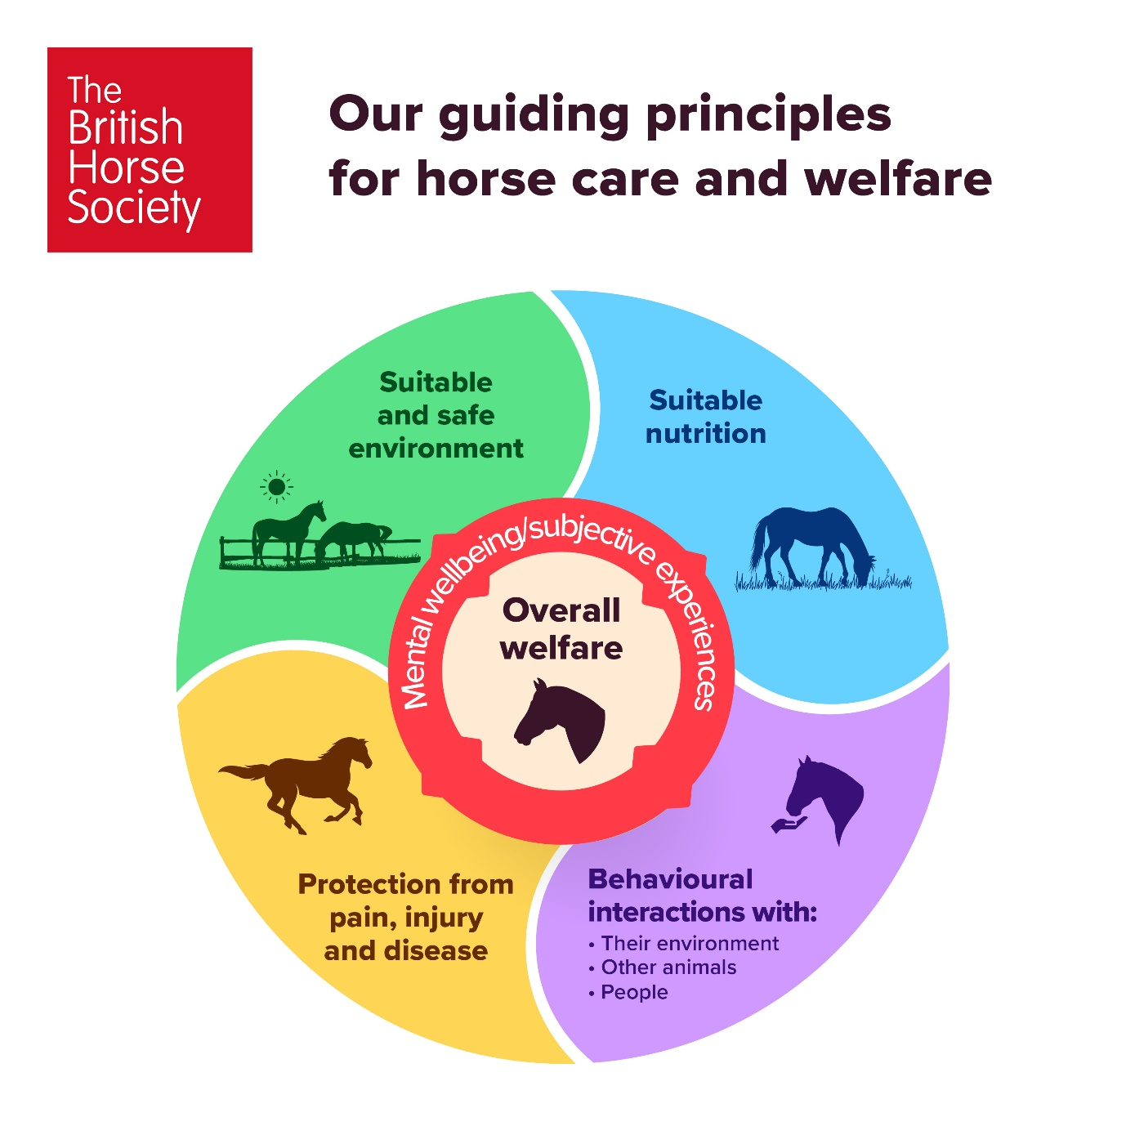
You can find further information about BHS Guiding Principles for horse care and welfare here.

- All riders should be a suitable size, in terms of height and weight, for their horse. Below is a summary of factors which influence a horse’s weight carrying capacity and should be taken into consideration when assessing rider suitability.
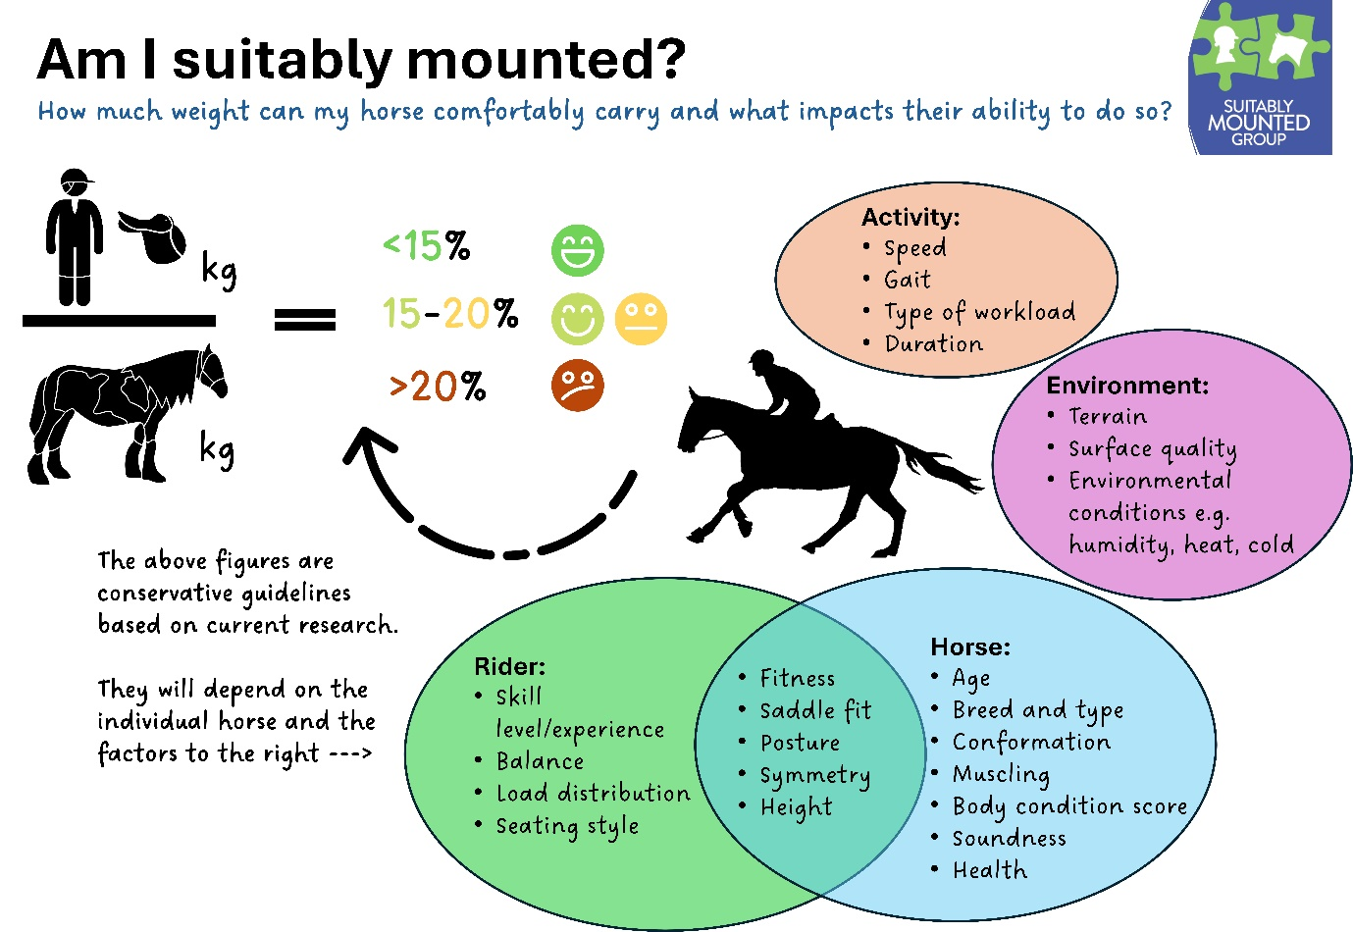

- Clipped or shaven sensory hairs around the mouth, nose, eyes and inner ear are strongly discouraged as this may reduce the horses’ sensory ability.

- Mares in foal may not take part after their 6th month of pregnancy, neither can mares take part in activities with foals at foot

- All horses should be passported and microchipped as required by equine identification legislation.

Stallions must be noted on all activity application/entry forms. If being stabled, every effort will be made to ensure they are situated in the best possible environment. A stallion disc MUST be displayed on each side of a stallions bridle at all times. Stallions must be led from a bit with reins or with a lead rope of a minimum length of 2.5m. No person may bring a stallion to a competition without ensuring, at all times, that competitors, ponies/ horses and members of the public are not put at risk.
The event organiser may, if they consider that a stallion may cause an accident or injure another person or pony/horse attending the competition, disqualify the stallion and direct that it be returned to its horsebox and be removed from the site.

- Forbidden Substances (banned substances & controlled medication) – ponies or horses taking part in competition must be healthy and no substances can be used which may mask an underlying health problem.

Exercising
Participants may exercise their horses/ponies in the areas provided. Riders are to behave with consideration to their fellow participants:
  - pass left hand to left hand
  - make tack adjustments where safe to do so
  - to avoid accidents, announce that you intend to enter an indoor practice arena
  - do not halt or walk on the outside track
  - give way to the faster pace and lateral movements.

If a warm-up arena becomes overcrowded, the organiser or steward may impose a limit on the number of horses allowed, giving priority to those closest to their time.

Lungeing of ponies/horses must not take place in such a way or at such times as to interfere with other competitors and/or spectators.

PPE
All riders/handlers must wear appropriate clothing suitable for the activity they are taking part in. Riders and handlers must wear protective headwear, whereby harnesses must be correctly adjusted and fastened at all times, and gloves are recommended. A body protector is also recommended for riders.

Participants are strongly advised to check their hats regularly and to replace them if damaged or following a fall. It is recommended that hats are replaced every 3 to 5 years depending on usage. We recommend protective headwear which meets one of the following standards:
British | PAS 015: 2011 provided they are BSI Kitemarked or Inspec IC marked
 | VG1 01.040: 2014-12 provided they are BSI Kitemarked or Inspec IC marked
European | EN1384: 2023 provided they are BSI Kitemarked or Inspec IC marked
American | ASTM F1163: 2004a or 04a onwards provided they are SEI marked
 | SNELL E2016 or 2021 onwards
Australian & New Zealand | AS/NZS 3838: 2006 onwards provided they are SAI global marked

BHS is committed to ensuring inclusivity and celebrates diversity within our activities by removing barriers to participation. Where specific items are worn on religious or cultural grounds that conflicts with BHS recommendations, please contact DEI@bhs.org.uk with details for advice.

Equipment
No item of saddlery or equipment may be misused. All saddlery and equipment is to be correctly fitted, used as intended in its manufactured state without adaptations and must be available for general purchase.
Section 2

Use of the whip
Consideration should be given as to whether a whip is necessary. If used, the use of the whip must be for an appropriate reason, at an appropriate time, on the correct area of the horse and with the appropriate level of response.

Appropriate Reason: The whip must only be used as an aid to support the natural aids in encouraging the pony/horse forward, or to help the rider to encourage the pony/horse in the right direction. For example, it may be used down the shoulder to keep a horse straight on the approach to a fence.
It must never be used to vent a rider’s temper or as punishment; any use for such a reason is automatically excessive.

Appropriate Time: As an aid, the appropriate time is when the pony/horse is reluctant to go forward under natural aids i.e. seat and legs. Its use, for instance, after a refusal is excessive. Its use after elimination is excessive.

Right area of the horse: As an aid to go forward the whip may be used down the shoulder or behind the rider’s leg. The use of a whip on a pony’s/ horse’s head or neck is always excessive use.

Appropriate Level of Response: the whip should never be used more than three times during any incident; and if the pony/horse is marked by the whip (skin broken or a welt) its use is excessive. (The rider is expected to know if the pony/horse has sensitive skin and must use the whip accordingly). The arm should never be raised above the shoulder whilst using the whip. The whip should always be carried and used in the backhand (handle pointed upwards) position and never in the forehand position (handle pointed downwards).
Misuse of a whip: If, in the opinion of the organiser/steward/official, a whip is misused/overused, the rider may face disqualification from the event.

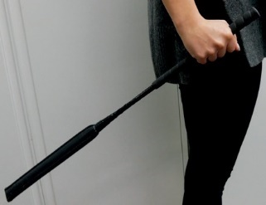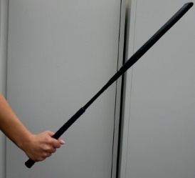
Correct Incorrect

One whip is permitted and must be between 45cm and 75cm and must not be weighted or feature a hard point at the end. The end of the whip must be padded. The ‘pad’ must be smooth with no protrusion or raised surface (which includes embroidery) and be made of a shock absorbing material throughout its circumference. No substitute for a whip may be carried.

Use of Spurs
Consideration should be given as to whether spurs are necessary. If used, spurs must not be used to reprimand a pony/horse. Such use is always excessive, as is any use that results in a pony/horse being marked by a spur. Misuse of spurs will render the rider liable to disqualification.

Spurs must be made out of smooth material (metal or plastic), including the band around the heel which must be blunt and be incapable of wounding a horse. The overall length of the spur is not to exceed 4cm from the back of the boot to the end of the spur in its entirety. Only one pair of spurs may be worn and must be securely fastened in the traditional manner, with the curve, if any, pointing downwards with the shank pointing to the rear and the end clearly horizontal to the ground or pointing downwards. Swan neck spurs are permitted as are dummy spurs. Rowel spurs are permitted but must be round, smooth and free to rotate. Fair Rider Spurs are permitted. Comb, tines and ‘spursader’ style spurs are not permitted.

Bits
The bit must never be used to reprimand a pony/horse. Such use is always excessive and will render the rider liable to disqualification and further disciplinary action.

2: CONDUCT OF PARTICIPANTS, OFFICIALS, VOLUNTEERS AND REPRESENTATIVES

BHS Members and representatives or associates of a member shall not:
    - Conduct themselves, before, at or after any BHS activity in a manner which is offensive to the public
    - At any event or activity, argue, behave with incivility or contempt, or use abusive or threatening language, towards a judge, official or other participant
    - Conduct themselves in a manner detrimental to the character and/or prejudicial to the interests of BHS
    - Make, either orally or in writing, to an officer of BHS or a third party, a statement on a matter covered by this code of conduct which they know to be untrue
    - Smoke when mounted
    - Officials are required to take decisions in a fair and sporting manner and in accordance with the code of conduct
    - Discriminate on the grounds of race, colour, religion or belief, disability, sex, marital status, age, sexual orientation, nationality and ethnic or national origins.

3: SAFEGUARDING

The British Horse Society is a Member Body of the British Equestrian Federation (BEF), and adheres to the BHS Policy on safeguarding.
We reserve the right to restrict or prohibit attendance at any of its events to anyone who we consider to be an unsuitable person. For our safeguarding policy and policy on unsuitable persons please see our website http://www.bhs.org.uk/safeguardingchildren

Children Participation
The BHS, or the training venue, cannot provide supervision for attendees under the age of 18. Any attendee below the age of 16 years should be accompanied by a responsible adult who remains at the venue for the duration of the course or event. For attendees aged 16-17, or an adult at risk, it is at the discretion of their parent or guardian and agreed in advance with the BHS or the training venue.

4: USEFUL CONTACTS

BHS General Enquiries: 02476 840500 or enquiry@bhs.org.uk

BHS Website

BHS Horse Care & Welfare: 02476 840517

BHS Safeguarding: 02476 840746

BHS Horse Passport Line: 02476 840574

British Horse Society, Abbey Park, Stareton, Kenilworth, Warwickshire CV8

Equine Register: Microchip Checker

Animal Welfare Act: Code of Practice for the welfare of horses, ponies, donkeys and their hybrids

