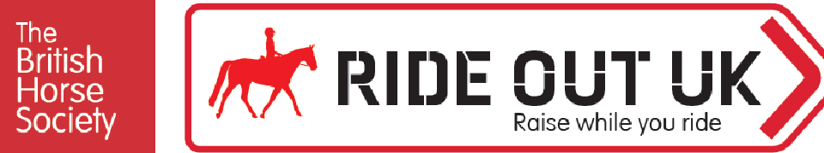
proudly supported by ,C
HORSE & COUNTRY

BHS Rideathon Adventure Distance Tracker
Name

Phone Email

The distance I am aiming to cover is My fundraising target is £

Date | Distance  Miles or kilometres | Where did you go? | What did you do? Riding, carriage driving, cycling, walking
TOTAL DISTANCE

If you need to add more lines, you can keep track on a separate sheet.

Send your Rideathon Adventure tracker to us
At the end of the Rideathon Adventure on the 37 October 2022, make sure to send your tracking form into us. To be in with a chance of entering our prize draw, you'll need to send your tracker and fundraising to us by 14 November 2022.
- By emailing a digital copy to access@bhs.org.uk, or
- By post to: The British Horse Society, Access & Rights of Way Team, Abbey Park, Stareton, Kenilworth, CVS 2XZ.

How have you fundraised?
I have fundraised a total of £ for the BHS Ride Out Fund.
- ☐ Via JustGiving
- ☐ Sponsorship form (make sure to send this to usl)
- ☐ Another online fundraising tool called _

Need some help?
Contact the Access & Rights of Way Team on access@bhs.org.uk or call us on 02476 840 575.

The Rideathon Adventure is part of the BHS Ride Out UK fundraising campaign. Visit www.bhs.org.uk/rideoutuk to find out more.
The British Horse Society is a Registered Charity Nos. 210504 and SC038516

