BHS Event Safety File Template
V2 2019

Introduction

A Safety File can be a useful tool for any activity that you are running for the BHS. It should contain all of the information you may need in the event of an incident and should be present at the event.

This template has been created to give a starting point for Organisers when thinking about what they might want to include in the Safety File. The entire content of this template can be edited, giving Organisers the option to amend, update, delete or add to the template information. You may not need all of the sections in this template for your activity, so you can simply delete accordingly.

This first page is a list of user instructions and notes and does not need to be included in the final Event Safety File.

Explanatory notes to assist you in filling in each section are in green. These can be deleted in your final version.

It is fairly self-explanatory where you need to replace the template information with your correct details; however things that require specific attention are marked in yellow.

Safety files can be kept as an electronic document or as a printed document, but they should be easily accessible throughout the event. It is usual that key officials including medics and vets are issued with a copy of the safety file at the event safety briefing, so they are also aware of the emergency plans for the event.

Important note about GDPR: As Event Safety Files contain personal names, addresses and telephone numbers, GDPR is applicable to their use. It is therefore a good idea to ‘sign out’ and ‘sign in’ any safety files that are shared with officials at the event. These can then be securely disposed of after the event. If each copy of the Safety File is numbered, then a sign out sheet can be used like this:

Name of Event SAFETY FILE LOG
Number | PRINT NAME  OUT | Sign Back In
1
2
3
4 …etc

EVENT SAFETY FILE

Name of Organising Committee

Name of Event

Date of Event

Venue Address
Venue Postcode
OS Grid Reference: Venue grid reference
(Use this website to find a grid reference: https://gridreferencefinder.com/ )

Emergency Radio Channel = xx
This is a separate channel that you could use if you needed to have a discrete conversation. Relevant Officials would be alerted to switch to this channel by a simple code such as ‘Go to Aintree’.

CONTENTS PAGES

Section 1 Health & Safety Policy Statement 3

Section 2 Event Organisation – Officials 4

Section 3 Emergency Contact Telephone Numbers 5

Section 4 Risk Assessment – Overview 6

Section 5 Timetable 6

Section 6 Serious Incident Protocol 7

Section 7 Site Plan 8

Section 8 Fire Evacuation Plan 8

Section 9 Radio Deployment 8

Section 10 Location Map 9

Section 11 Event Risk Assessment 9

Section 12 Safeguarding Plan 9

Section 1 Health & Safety Policy Statement
This is a copy of the BHS Event H&S Policy Statement Template v2 2019. It should be edited as applicable to your particular event.

General:
The Organiser, (Organiser’s Name) has overall responsibility for Health and Safety.
The event is organised in accordance with Health and Safety Legislation and all who have, to any extent, control of the premises on which the event is held, are responsible for ensuring that:

• Everything reasonably practicable is done to ensure the health, safety and welfare of those attending the event
• They conduct themselves so that they do not put themselves or anyone else at risk • The access to and egress from the site is safe and unobstructed

Officials:
Stewards and Officials are briefed to conduct themselves so that they do not put themselves or anyone else at risk, and to maintain control of the area around their location.

Spectators:
All reasonable and practical steps have been taken to ensure the health, safety and welfare of those attending this event.

Competitors:
Competitors are required to conduct themselves, and retain control of their horses, so that they do not put themselves or anyone else at risk.

Contractors:
Contractors at this event are required to observe best working practices, complying with all health and safety legislation relevant to their business, and take all reasonable and practical steps to safeguard the health and safety of their employees and any other person attending the event.

Trade Stands:
Trade stands are responsible for the safety of their own stands and the risks that they may pose to employees and any other persons within the allocated space or immediate surrounding areas.

Horses:
Horses can easily be frightened and can be dangerous. Members of the public are requested to keep clear from horse areas/lanes and to avoid behaviour that might alarm horses.

Dogs:
Dogs should be kept under close control and on a short lead.

Emergencies:
• Emergency services must have access to all parts of the event site at all times and the designated emergency access routes must not be obstructed.

• First aid points are clearly marked and the medical cover at this event includes Paramedics and First Aiders. Medical support can be contacted through any Official or by dialling 999.

• All accidents or near miss incidents should be reported to the Organiser for appropriate support to be deployed.

Section 2 Event Organisation – Officials
Add in any other key Officials you may have at your event. Those not applicable can be deleted.

Role | Name
Venue Owner | Insert names below

Event Director / Organiser

Chief Steward

Health & Safety Advisor / Responsible Person

Event Secretary

Other Committee Members Present

Photographer

First Aider

Paramedics

Vet

Farrier

Horse Ambulance

Stable Manager

Car Park Steward

Scorers

Score Collectors

Show Jumping Course Builder

Show Jump Steward

Show Jump Tack Steward

Show Jumping Commentator

Show Jump Judge

Show Jump Arena Party

Dressage Steward

Dressage Tack Steward

Dressage Judge

Dressage Writer

Section 3 Emergency Contact Telephone Numbers
Add in any other key Officials that may be applicable. Those not applicable can be deleted.

In the event of an emergency the Senior Official at the scene will be responsible for contacting all necessary emergency services.

Service | Name | Contact Number
Ambulance | n/a | 999 or add Local Number
Air Ambulance | n/a | Add Local Contact Number
On site First Aider / Paramedic | Insert Name | Insert Number
Local Hospital (that is open during event hours) | Insert Address | Insert Number
Out of Hours Medical Cover | NHS 24 hours | 111
Vet on Site / On Call | Insert Name | Insert Number
Police (non-emergency) | n/a | 101
Fire Brigade | n/a | 999 or add Local Number
Horse Ambulance | Insert Names below | Insert Numbers below
Farrier

Venue Owner

Event Director / Organiser

Chief Steward

Health & Safety Advisor / Responsible Person

Event Secretary

Other Committee Members Present
Stable Manager
Vet Referral Practice
Horse Disposal
BHS Emergency Number | BHS HQ Staff | 02476 840 472

Section 4 Risk Assessment – Overview
This should give a brief outline as to the type and size of the activity. Rows not applicable can be deleted.

Description of Event | Indoor show jumping max height 80cm and Prelim dressage
No of Competitors | Approx 100
No of Spectators & Connections | Approx 50
No of Lorries & Trailers | Approx 80
Access for Competitors | Main gate controlled by a steward
Access for Spectators | Main gate controlled by a steward
Exit | Main gate controlled by a steward
Parking Areas | Equestrian centre lorry park with overflow on grass behind the indoor school
Area Available | Adequate – additional space available if required
Ground Conditions | Parking mostly on hard-core. Competition all on surfaces.
Security | Competitor and public access at own risk
Camping | On site camping in fenced off area of grass adjacent to the lorry park

Section 5 Timetable
Add in the planned timetable for the activities. It can be useful to hold a safety briefing for key officials including medics and vet.

Example:
Safety Briefing at 0800

Ring /Arena | Time | Class
Indoor | 0830 – 1158 | 80 Show Jumping 1st Round
Indoor | 1300 - 1618 | 80 Show Jumping 2nd Round
Arena Walk | 0730 - 0800
Arena 1 AM | 0830 - 1148 | Prelim 2 Team
Arena 2 AM | 0830 - 1148 | Prelim 7 Team

Section 6 Serious Incident Protocol
1. The Serious Incident Protocol team (SIP) will be led by Organiser (Name of Organiser) and assisted by Steward (Name of Steward).

2. In the event of an incident (insert name) would take over the running of the event.

3. The members of the SIP are:
Add in any other Officials that may be applicable. Those not applicable can be deleted.
Insert Names Below | Event Director / Organiser
 | Chief Steward
 | Venue Owner
 | Health & Safety Advisor / Responsible Person
 | First Aider / Paramedics
 | Vet
 | Horse Ambulance
 | Family Support / Hospital Liaison

4. It is the wish of the BHS to continue with the running of the event if possible.

5. In the event of a fatality or possible fatality, the Police must be notified. This is the responsibility of the SIP Team and should be done as soon as possible after the incident has occurred.

6. Removal of deceased person can only be authorised by the HM Coroner; however this will not stop medical teams transferring potential deceased to ambulance for life extinct assessment under the control of the senior medical official present. In the event of a rider fatality the body will be retained in the ambulance or moved to the site office if needed.

7. A seriously injured horse or horse fatality will be dealt with by the veterinary surgeon and the horse ambulance. The body would be removed to the far field to await collection.

8. In the case of a seriously injured horse or horse fatality the paramedic or doctor will be asked to attend to support the rider and any associated people.

9. Any equine surgery cases will be handled by: Insert vet referral practice name, address and telephone number.

10. Horse Disposal – Insert details

Section 7 Site Plan
A basic layout of the venue can be useful to officials not familiar with the site. It is also useful to include any XC fence lists.

Insert map of site here

Section 8 Fire Evacuation Plan
If you are using a permanent venue, then they should have a fire evacuation plan which you can add in here. If horses are staying on site overnight, then thought should be given to where you would evacuate stabled horses to in the event of a fire. This may be into an adjacent field or arena.

Area to Evacuate | Evacuation Point
Stable Block A | Adjacent paddock
Stable Block B | Indoor Arena

Section 9 Radio Deployment
This table can be used to check out and in any radios, noting who has which number.

Using Channel XX Insert the channel number that will be used for general communication.

Role | Name | Radio Number | Sign In | Sign Out
Event Director / Organiser | Insert Names Below
Chief Steward
SJ Commentator SJ
Stable Manager
Secretary
Scorers
Health & Safety Advisor
Car Park Steward
Vet
Horse Ambulance
First Aider / Paramedic
SJ Steward
Dressage Steward

Section 10 Location Map

A map of the local area can be useful if having to direct emergency services to you.

Example:

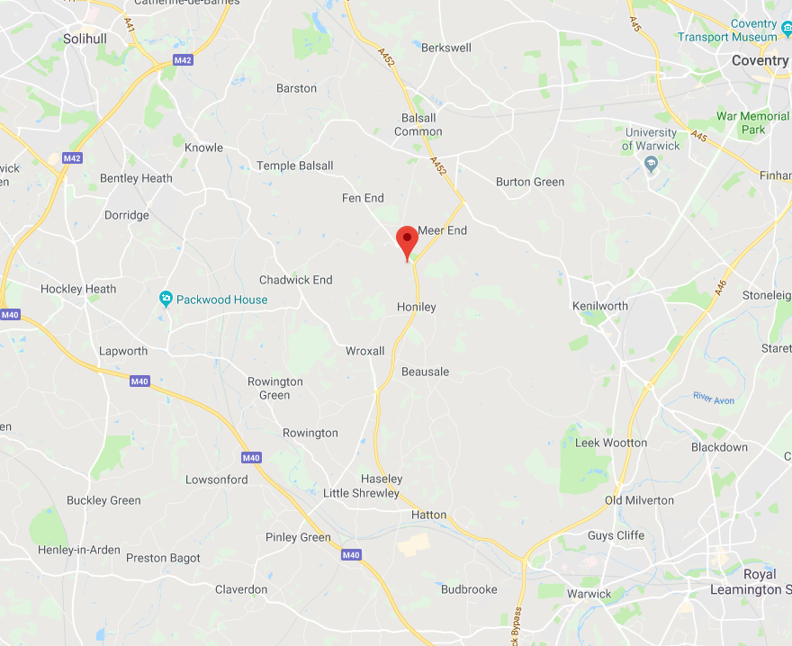

Section 11 Event Risk Assessment

Insert Event Risk Assessment Here.

See ‘BHS Event Risk Assessment Template v1 2019’.

Section 12 Safeguarding Plan

Insert Event Risk Assessment Here.

See ‘BHS Event Safeguarding Plan Template v1 2019’.

END OF DOCUMENT

