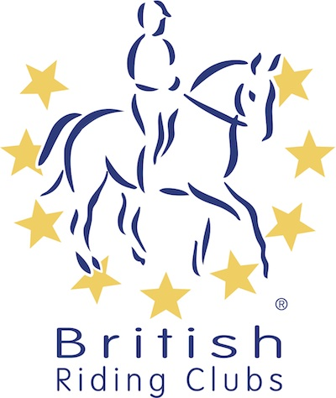
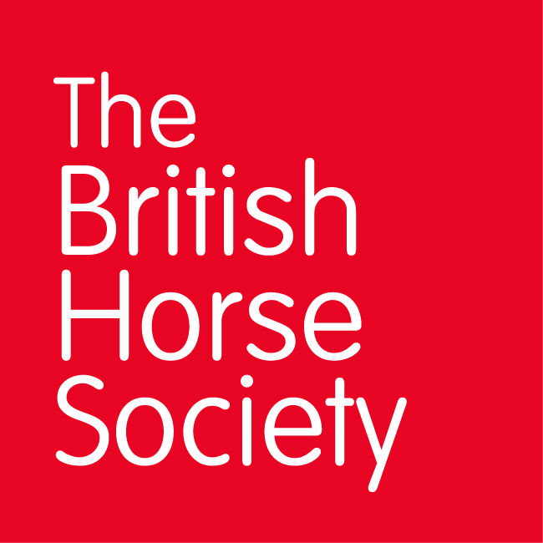
BRC CHAMPIONSHIPS 2025
AREA 6 SUMMER QUALIFIER DATES

COMPETITION | DATE | VENUE | ORGANISER | Official  Steward
Combined Challenge | 29/03/2025 | Tweseldown, Bourley Rd, Church Crookham, Fleet GU52 8AD | Tweseldown Racecourse | Jane Skeats
National Champs (Show Jumping) | 11/05/2025 | Berkshire College of Agriculture, Hall Place, Burchetts Green, Maidenhead SL6 6QR | Irene Harper | Deb Ibbott
Horse Trials | 08/06/2025 | Munstead Horse Trials, Heath Lane, Godalming, Surrey, GY7 1UN | Munstead Horse Trials | Peter Dryzek
National Champs (Dressage) | 15/06/2025 | Berkshire College of Agriculture, Hall Place, Burchetts Green, Maidenhead SL6 6QR | Debs Grigg | Deb Ibbott
Combined Training | 28/06/2025 | Berkshire College of Agriculture, Hall Place, Burchetts Green, Maidenhead SL6 6QR | Irene Harper | Peter Dryzek
Closing dates for all qualifiers are 21 days before the event.
Please note qualifiers should be held at least 28 days before the Championship date.

