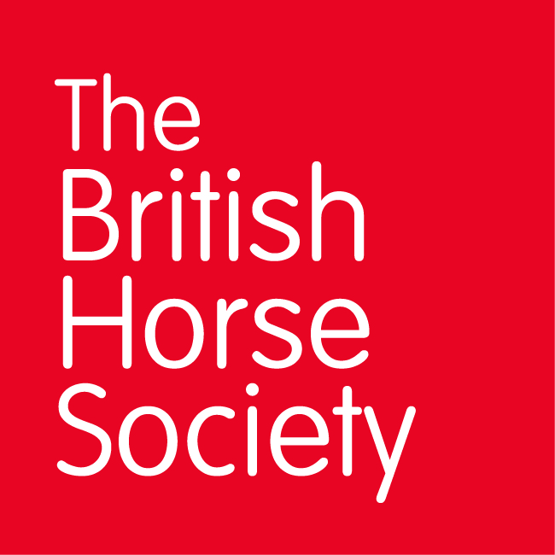BRC CHAMPIONSHIPS 2022
AREA 06 SUMMER QUALIFIER DATES
COMPETITION | DATE | VENUE | ORGANISER | Official  Steward
Horse Trials | 28/05/2022 | Snowball Farm | Irene Harper,  1 Cliffords Way,  Bourne End,  SL8 5TR.  07974 938685  irene.harper170@btinternet.com | Peter Dryzek  07767 457929  peter.dryzek@gmail.com
Summer Dressage | 19/06/2022 | Henley Showground, Hambleden | Gina Beamish,  2 Pump Lane North,  Marlow,  SL7 3RD.  07725 338251  rioeventing@gmail.com | Kellie Jones  07508 188156  kellie.ej76@gmail.com
Dressage to Music | 21/08/2022 | Berkshire College | Kellie Jones,  Lily, Thames & Kennet Marina,  Henley Road,  Caversham,  RG4 6LQ.  kellie.ej76@gmail.com | Jane Skeats  07504 038370  janeybe@hotmail.com
Introductory Dressage | 21/08/2022 | Berkshire College | Kellie Jones,  Lily, Thames & Kennet Marina,  Henley Road,  Caversham,  RG4 6LQ.  kellie.ej76@gmail.com | Jane Skeats  07504 038370  janeybe@hotmail.com
Summer Show Jumping | 10/07/2022 | Berkshire College | Irene Harper,  1 Cliffords Way,  Bourne End,  SL8 5TR.  07974 938685  irene.harper170@btinternet.com  Lara Booth,  19 Circuit Lane,  Reading,  RG30 3HB  07715 759555  lara.booth@genesys.com | Helen Howard  07786 673527  howardhj@btinternet.com

Closing dates for all qualifiers are 21 days before the event.
Please note qualifiers should be held at least 28 days before the Championship date.

