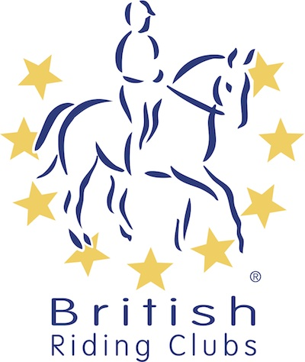
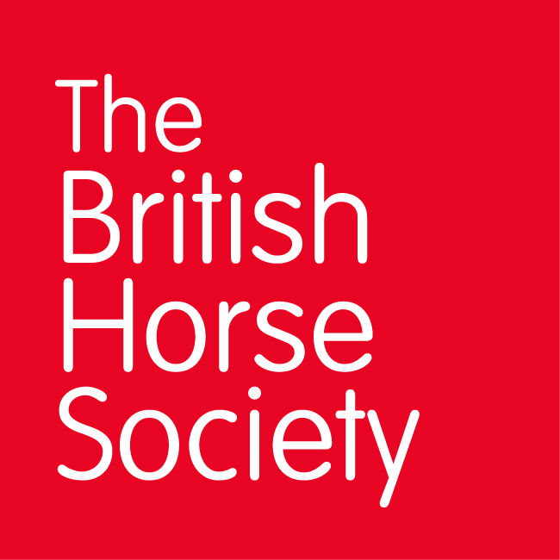
BRC CHAMPIONSHIPS 2025
AREA 10 SUMMER QUALIFIER DATES

COMPETITION | DATE | VENUE | ORGANISER | Official  Steward
Combined Training | 10/05/2025 | Felbridge Show Ground | Lindsey Bootes | Jean Bywater
Horse Trials | 25/05/2025 | Blindley Heath Horse Trials, Show Site, Blue Anchor Farm Cottages, Eastbourne Road, Blindley Heath RH7 6JL | Lucy Cunliffe | Jean Bywater
Combined Challenge | 07/06/2025 | Lodge Farm EC | Lodge Farm EC | Jean Bywater
National Champs (Show Jumping) | 14/06/2025 | Hadlow College, Tonbridge Road, Hadlow, TN11 0AL | Scott Ponton | Jean Bywater
National Champs (Dressage) | 12/07/2025 | Hadlow College, Tonbridge Road, Hadlow, TN11 0AL | Scott Ponton
Horse Trials (70cm) | 20/07/2025 | Lodge Farm EC | Rother Valley, Friend’s of Freddie | Jean Bywater
Closing dates for all qualifiers are 21 days before the event.
Please note qualifiers should be held at least 28 days before the Championship date.

