BRITISH RIDING CLUBS
NAF FIVE STAR HORSE TRIALS CHAMPIONSHIPS
4 – 6 AUGUST 2023 – SWALCLIFFE PARK

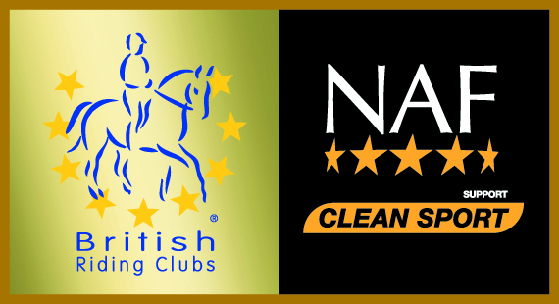

Call Me Finn Memorial Trophy Entry Form

A trophy will be awarded in memory of Call Me Finn to the highest placed veteran horse (15years +) individual in the Senior 90 class. Please give details below if this applies to you. Entries close 60 minutes before the start of the class.

Entries close 30mins before the class begins

ENTRY DETAILS

CLUB
RIDER NAME

MEMBERSHIP NO

HORSE

HORSE AGE

OFFICE USE ONLY

COMPETITOR NUMBER

Personal information that you supply to us may be used in a number of ways to facilitate your riding club membership. Your personal information will be shared with associates for the purpose of fulfilling your full membership benefits i.e. insurance providers. BRC will automatically contact you about your membership: for example, to ensure you receive your membership benefits, to tell you about news, activities and events. This includes sending you a regular magazine, email updates, information on other membership benefits, and publishing competition times and results in the public domain.

To see our full Privacy Policy, or if you need any further information, please write to us at; British Riding Clubs, British Horse Society, Abbey Park, Stareton, Kenilworth, CV8 2XZ or go to: http://www.bhs.org.uk/privacy

CONTACT DETAILS

Team Manager Name & Contact Number:

This person will act as emergency contact on the day
YES/NO (please circle)

If NO please provide an emergency contact name and number below
Emergency Contact Name & Number:

Forms to be returned to brcentries@bhs.org.uk

