[Your Name]
[Your Address]
[Your Address]
[Your Address]

[Today’s Date]

[Landowner’s Name]
[Landowner’s Address]
[Landowner’s Address]
[Landowner’s Address]

Dear [Landowner’s Name],

I have problems managing the sustained occurrence of ragwort on my grassland. I am writing to seek your help to control the risk of ragwort spreading from your property to mine.
Ragwort is a common weed that presents a danger to horses if allowed to spread into pastures grazed by them. It contains toxic compounds which can cause irreversible liver damage. It is equally as toxic if it is cut, dried and included in forage like hay. Ragwort spreads quickly and easily. You may have already noticed ragwort on your land, but to be clear it can be identified as follows:

First Year Growth: Rosette stage
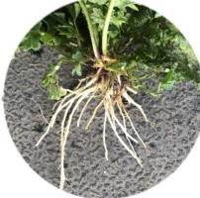
Even at rosette stage, roots are numerous, relatively thick
and quite tough

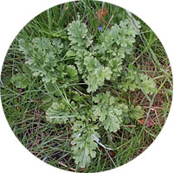
Rosette growth can vary greatly -as the rosette develops, the leaves look irregular with jagged edges

Second Year Growth: Plant stage
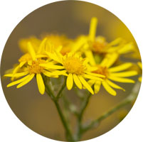

Flowers usually appear from June to late October - plants have large, flat-topped heads of dense yellow flowers that can be extensive

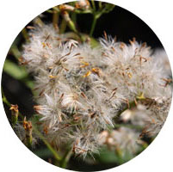

Seeds ripen in July/August and are normally shed from September. One plant can produce thousands of seeds, which can lie dormant for years.

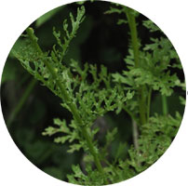
Leaves are dark green and quite tough. Leaves are deeply divided with irregular, jagged edges.

In its first year of growth, the low-lying rosettes can be hard to spot after May because the grass is tall enough to hide it, so it is important to catch all of it earlier in the spring. The ones that are missed in year one may be caught in their second spring, or after June when the flower spike begins to rise and make them easier to see. We tackle it all through the year – once we have seen it, we return with the fork promptly to deal with it. None is allowed to set seed here. It involves a lot of work, but it is essential to protect our horses. We are obliged to spend hours clearing our own ragwort throughout the season. It is exasperating to find that new plants are constantly emerging with some arising from seed blown in from neighbouring land.
Ragwort is a specified weed under the Weeds Act 1959. If ragwort is within 50m of ‘vulnerable land’ - i.e. land used for horses / livestock pasture / land used for forage production - it is classed as high risk and landowners/occupiers are obliged to control the ragwort to prevent further spread. Control of high risk ragwort is vital to safeguard horses from its devastating effects.

I have attached a map [available from XXX] which shows the boundary of my property and specifically highlights any grazing or hay meadows where we are obliged to spend hours clearing our own ragwort throughout the season.

The map also gives an indication of the 100 metres reach beyond my boundaries where, under the Code of Practice on How to Prevent the Spread of Ragwort, an obligation arises for my neighbours to control their ragwort, before it seeds, so that it does not spread to my vulnerable land. Where the prevailing wind assists the seed in spreading, we would like to agree a limit beyond 100 metres as has been shown on the map. Addressing the problem can be left until the plants are in flower so that it is easy for you to identify them, but please be sure to commence dealing with it during June at the latest before the plants go to seed. You may find some plants emerge later and so a second purge may become necessary.

Ragwort is biennial (taking two years to fully grow and flower) and its seeds lie dormant within the ground for years before germinating. This means removal methods may have to be used annually until the weed is brought under control. A combination of different removal methods may be needed.

Option: Hand Pulling | Option: Herbicide Treatment
- Appropriate for smaller areas of land.  - Make sure the whole of the root is removed, as any fragments of the root left within the soil will result in the ragwort regrowing.  - Best results are achieved when the soil is damp.  - Ragwort-specific hand tools (Rag-Fork) are available to help with successful root removal.  - It is advisable to wear gloves when handling the plants. | - A risk assessment must be completed.  - Approved products are listed on the Pesticide Safety Directorate at pesticides.gov.uk. Local agrochemical companies can also help.  - Some products require a qualified specialist to carry out the application. Details are available from the National Association of Agricultural Contractors at naac.co.uk.  - The herbicide should be applied when rosette growth is seen in spring (herbicide treatment at the plant stage is likely to be ineffective).  - Apply the herbicide on a mild, calm day, ensuring the vegetation is dry and that rain is not expected for at least a few hours.  [If animals on land:  Animals must be moved to alternative grazing before the herbicide is applied to the land.  It’s only safe to return horses once all the ragwort has fully disintegrated. This can take a few weeks, so follow the product specific guidelines carefully. Remember that dead ragwort is still toxic and palatable.]

The Code of Practice refers to mowing/cutting as being a control method of last resort. Cutting stimulates growth and it is unlikely to have any impact on controlling the spread of ragwort and can turn the plant perennial. Flowering ragwort that has been cut is still capable of seeding and cut ragwort is more palatable when dry. The plant will also just regenerate a new flowering head in a few weeks’ time and so the problem starts again.

Our method is [to pull it – roots and all – assisted by a fork to ensure we get it all. We then incinerate it as soon as we can. We tackle it all through the year – once we have seen it, we return with the fork promptly to deal with it. It is crucial that none is allowed to set seed here].

I really hope you understand my situation and want to help prevent the spread of ragwort by [removal of ragwort on your land / attending to this chore each spring on your land]. Your support would be so much appreciated.

Kind regards,

[Your Name]

